**UNIVERSITY OF HERTFORDSHIRE**

**School of Computer Science**

**BSc Honours in Computer Science**

**6COM1054 - Artificial Intelligence Project**

**Final Report**

**April 2019**

**Water Cleaning Agents**

**B. L. Nichifor**

**Supervised by: Irenaeus te Boekhorst**

**Abstract**

Plastic waste is ubiquitous and is reported globally, from the surface to sediment. Plastic pollution in freshwater and marine environments have been identified as a global problem. [G.Kibria, 2017] During this project, I will be developing the idea of an amphibious autonomous agents that will traverse water environments as a swarm detecting waste and collecting it. The steps taken will be conveyed throughout the report in respect to the Contents Page.

Due to time constraints the agents will not be manufactured but all steps before manufacturing will be covered. This includes materials used, dimension research and material research. The agents will be visualised in a NetLogo simulation which will cover the agents functionality and features in a basic environment. The NetLogo simulation will be further used for testing purposes to find the most efficient way of running the agents by exploring the included features and potential of the agent.

Throughout the report, I will talk about the project as a whole, planning and designing it while documenting each step to ensure a concise and well-structured description.

In the evaluation section of the report, the final project will be analysed as a whole against its goals, aiming at finding strengths, weaknesses, possible improvements and future plans.

Appendix A includes a user manual for the simulation, and it is suggested to read it before going through the report.

**Acknowledgement**

Before we start, I would like to direct my gratitude to Irenaeus te Boekhorst my project supervisor for the consistent guidance and support during the project period through meetings, active emails and helpful tips helping me to adequately carry out my project.

A user manual is included at the top of the appendix which I encourage reading for a better understanding of how the simulation works.

**Table of Contents**

1.Introduction………………………………………………………………………………...............4-7

## 1.1 Project Overview………………………………………….....................................4

1.2 NetLogo.........................................................................................................4

1.3 Swarm Intelligence.......................................................................................4-5

## 1.4 Reasoning for this project……………………………………………………………...5

## 1.5 Project Goals ………………………………………………………………………………….5-6

## 1.6 Project structure …………………………………………………………………………….6-7

# **2.Research…………………………………………………………............................................7-9**

2.1 Introduction……………………………………………...…………………………………………….7

2.2 Seabin............................................................................................................7

2.3 The Ocean Cleanup .......................................................................................8

2.4 SeaVax............................................................................................................8-9

2.5 Requirements.................................................................................................9

**3.Design Stage...............................................................................................10-14**

3.1 Materials Used............................................................................................10-11

3.2 Initial Design................................................................................................11-13

3.3 Features Analysis........................................................................................13-14

**4.Implementation..........................................................................................14-18**

4.1 NetLogo Simulation....................................................................................14-18

**5.Testing........................................................................................................18-27**

5.1 Code Testing...............................................................................................18-22

5.2 Parameter Testing......................................................................................23-27

**6.Discussion and Evaluation..........................................................................27-28**

6.1 Discussion...................................................................................................27-28

6.2 Evaluation.........................................................................................................28

**7.Conclusion..................................................................................................28-29**

7.1 Final Design......................................................................................................29

7.2 Conclusion........................................................................................................29

**8.Bibliography.....................................................................................................30**

8.1 References.......................................................................................................30

**9.Appendixes.................................................................................................31-45**

9.1 Appendix A – User Manual.........................................................................31-35

9.2 Appendix B – Implementation and Testing................................................36-39

9.3 Appendix C – Full Code..............................................................................40-45

# 1.0 Introduction

# 1.1 Project Overview

The aim of this project is to plan and design an amphibious agent to traverse different water environments. The agents will collect refuse with the aim of clearing the water of pollution and dispose of it correctly. The agent will traverse rivers oceans and lakes using varying sensors for object detection and pumps for propulsion, collecting waste in the sea and avoiding any obstacle that may be in its way. Alone a single agent may not make a noticeable difference, but a flock of agents working together in unity, following simple rules it can develop into a real plausible solution to one society’s paramount problem.

1.2 NetLogo



As part of this establishment I will be using NetLogo to create a simulation used to display the proposed agents in a basic environment. NetLogo is a free, multi-agent programmable modelling environment which can be used to author simulations models from scratch (Uri Wilensky, 2019). The use of NetLogo benefits this project as it means that it can used to find the most ideal approach to running the agents without having to use money and time to assemble such prototypes.

The NetLogo simulation will serve as a testing tool available to anyone looking to test, create or sponsor such agents. Users can change and edit settings and features to suit their needs. The simulation can also be easily adapted to suit other project and many options are already available to be changed without having to make changes to the source code.

1.3 Swarm Intelligence

The proposed agents will follow simple swarming rules to mimic swarm intelligence.

Swarm intelligence is an emerging field in artificial intelligence based on behavioural models of social insects such as ants, termites, bees etc. Applying swarm intelligence to agents means the agents follow simple rules and interact locally with each other and the environment. For this project, the agents will be programmed to work with a collective behaviour as they are collecting waste and although none of these agents are programmed to do this specifically, the effects of agents following simple rules converge on a solution.

The advantages of swarm intelligence are:

Flexible – Swarm responds to internal disturbances and external challenges

Robust – Task will be completed even if some agents fail

Scalable – Number of agents can always be increased

Decentralized – There is no central control

Adaptation – The swarm system can not only adjust to predetermined stimuli but also new stimuli

Speed – Changes in the network can be propagated swiftly

The disadvantages of swarm intelligence are:

Behaviour – Difficult to predict agent behaviour from individual rules

Sensitivity – Even small changes in the rules results in different group level behaviour

Action – Behaviour of agent may look like noise, as action of choice may not be predicted precisely.

(Techferry.com, 2019)

1.4 Reasoning for this project

The reason behind this project is because we live in a world that is currently not sustainable. Water pollution has become one of the top priorities towards sustainable development. For more than 50 years, the production and use of plastic has continued to rise due to its versatile, lightweight, durable and relatively inexpensive attributes. Overlooked often, however due to its durability and chemical structure, plastics are very slow to degrade, inevitably leading to waste that will be present for thousands of years. (Le Guern, 2019) Since the 1950s (Casson, 2019) states that only 9% of plastic has been recycled meaning most of it ends up in landfills and subsequently in our oceans. It is estimated that currently there is around 245,000 metric tons of plastic floating on the surface of our oceans. (Lindsay, 2019)

1.5 Project Goals

The objectives for this project will be outlined below to give a bigger picture of the motivation factors behind this project.

The motivating objective for this project is to use the concepts learned throughout the A.I modules to create a product that will not only use the concept of being autonomous but applying that to a global problem currently facing society.

The use of the Thymio robots in the final year sparked my interest for self-sustainable robots some of which already exist such as the Roomba hoover and Robomow, a robot that mows your lawn. I feel that this type of Artificial Intelligence has a much greater potential than to be used to hoover a person’s room and as a result I wanted to further explore the potential of it against a real-world, wide scale problem.

The aim is to use the already available agent concepts and apply it to an increasing world problem; water pollution. An agent can be designed and programmed such that it is suitable for water environments and similar to a Roomba sucking up waste will be able to detect and collect water pollution such as plastic bottles.

Since no water agents have yet been developed, this project will use other existing water cleaning projects to find out about the difficulties they faced so they can be avoided.

Knowing that building a real prototype and testing it in the given timeframe is highly improbable, the alternative is to use NetLogo, a multi-agent programmable modelling environment. Using NetLogo the aim is to show as many if not all of the features of the agent showing how it is expected to function when taking into account basic principles of a real environment.

As with any autonomous agent, parameters are used to calibrate the agents functionality, such as: how fast it should turn, how fast it should move, how far it can see, how big are the objects it should avoid, etc. The benefit of using NetLogo is that parameters can be changed extremely easy which makes testing and finding the optimal value much easier than having to use prototypes and tweak them each time. The aim is to use this feature of NetLogo to test a wide range of parameters and pick out the most optimal set to make the agent as efficient as possible.

Finally, the results and observations made will be used to design and document a real scale agent ready for manufacturing.

1.6 Project Structure

The following documents show how the research carried out was used to construct the requirements for the agent. Many of the projects researched have failed due to funding and technical problems. This research will be used to take the strength points from these projects and emulate them as an advantage. It is useful to show in detail how the requirements are constructed as it gives people a deeper understanding of the problems faced and how to overcome them.

Chapter Three consists of a description of all materials to be used in the construction of an agent and how they will work together.

Chapter four or the design stage concludes the requirements picked out in chapter 2 along with the materials in chapter 3 to design an initial prototype of the agent. This design will be used in the simulations to test and decide whether it needs to be refined. As a result, the initial design made here may be validated or changed later in the project.

Chapter 5 includes the implementation of the NetLogo simulation showing the steps taken towards the development of it. It will also include any the difficulties faced and how they were overcome.

Chapter 6 shows all testing done against the code to ensure it works as intended and there are no overlooked bugs. Any changes resulted from the testing process will be documented as such in this section. This chapter also includes all parameter testing conducted in order to find the parameters which resulted in the most efficient agent.

Chapter 7 includes an overall discussion about the project and any improvements that could be implemented within it. The discussion also covers the work planned for this project and the potential future progression. Furthermore, this chapter also covers the evaluation where all the steps completed to achieve the project goals are evaluated against the initial requirements.

Chapter 8 is the final chapter covering the overall conclusion of the project. The final design is decided as well as the final parameters to be used. Thereafter, the project is analysed against the requirements and goals set to decide whether or not they have been reached and how successful the project was overall.

**2.0 Research**

2.1 Introduction

Before beginning on the development of the agent, research was carried out on the subject of water cleaning robots and established that there are many projects currently coexisting that have the same goal. This section focuses on carrying out thorough research on the most popular water cleaning projects with the aim to learn from the mistakes they’ve made and benefit from the aspects they have done right.

2.2 SeaBin Project

The Seabin Project consists of a collection point that is located in the water at marinas, docks, yacht clubs and commercial ports. It works by sucking in water from the surface which passes through a catch bag. Using a water pump, the water is pumped back out; leaving the litter and pollution trapped in the catch bag for proper disposal. (SeaBin, 2019)

The SeaBin appears to be a very clinical way of cleaning the water. The use of removable nets means that these can be interchanged with various other nets for several purposes. The SeaBin CEO highlights in talks about the project that nets used to catch oil and microfibers are in development, which will certainly be helpful in further cleaning the oceans. Moreover, the SeaBin is known for not harming sea life during the process, mainly because fish and other sea life generally don’t stay on the surface of water and also because the pump is not strong enough to suck them in.

On the contrary however, through reading comments and articles, it was established that the CEO’s statement of the bins being low energy consumption were incorrect, and the power that it requires heavily outweighs any benefits it provides. The owner does mention that these can be adapted to run by solar wind and wave power, however they are still yet to offer such to the public. It seemed that also many critics were put off by the cost of these, coming at $4100 with additional high running and maintenance cost this is no surprise. The SeaBin is also immobile and is screwed into a single spot on the dock meaning it isn’t very versatile.

In conclusion, the SeaBin Project is one of the more popular water cleaning projects and it works well to clean water, however its high energy uses means that its invasive footprint heavily outweighs any good it is doing for the planet. With the right characteristics; use of renewable energy; smaller buying costs, this project would be very successful and very environmentally friendly.

2.3 The Ocean Cleanup Array

The Ocean Cleanup project consists of a 600m long floating array and a 3m deep skirt attached to it. The floating array allows the system to float and block any floating plastics from flowing over it, while the skirt stops it from floating underneath.

The use of an impenetrable skirt results in an important characteristic of not harming sea life. As it is not a net, there is no risk of sea creatures becoming entangled in it and the skirt at its deepest is only 3m meaning sea life can swim under it. The addition of the skirt means that this project is multi-dimensional as it helps to collect plastics not only on the surface of the water but underneath as well. The project itself is energy neutral as it relies on natural ocean currents for movement and any electronics are powered by solar energy. Additionally, the project is completely autonomous as it roams the oceans freely and is only tracked by satellite.

The Ocean Cleanup is a very promising project and is expected to clean up 90% of ocean plastic by 2040, however due to the nature of this project, it is only suitable for oceans and not other areas such as lakes or rivers. Furthermore, the cost of having a ship go into the gyres of an ocean to collect the plastic would be 1) very expensive and 2) borderline dangerous for the crew.

This project is a very promising solution for ocean clean-ups as the project is autonomous and energy neutral. The use of the skirt is very smart and provides huge benefits such as multi-dimensional collection to the project. The only downside to this project, however, is that it only covers oceans and is not suitable in any other environment.

2.4 SeaVax

SeaVax is essentially an autonomous solar powered ocean cleaning vacuum. It consists of a large vessel running of solar and wind power which collects plastics through a nossel at the front and stores it in a large storage area.

A creative design of SeaVax is that its solar panels are located on movable panels with the purpose of the ship being able to track the sunlight and facing the solar panels towards it to maximise energy gathered. This would be useful as to increase the efficiency of the agent by reducing charging times. SeaVax inclusion of the large storage area, meas that it can store more and thus has to do less back and forth trips to drop off the waste. SeaVax uniquely also focuses on the agents chances of surviving a storm and have claimed to have maximised this by having a heavy agent and clever algorithms which make the agent face the waves during a storm making it less likely to flip over.

However, SeaVaxs vacuum means that it can interfere with sea life and although they claim that it will have a sea life sensor, that may not be very affective, and seems unlikely that at any given time if the sensor would go off a manned ship will be sent out to clear it. The size of the SeaVax also means that it is not suitable for all environments such as small rivers and lakes as deploying it and transporting it would prove to be very difficult.

Overall, the SeaVax has very good potential to become a reliable sea cleaner and the use of renewable energy and it being autonomous are its strong points. The introduction of a storage area is very convenient for a fully autonomous agent as it reduces time that has to be spent emptying it. However, the scale of this project means that it will be a long time before the funding for it is secured and even longer before one is seen in action if it is at all.

2.5 Requirements

By researching the different projects, their assets and drawbacks can be used to learn from. Further, this can be used to avoid stepping into the same mistake and use their good features to construct a water cleaning agent that will be good for the environment overall and will be accepted by the general public. Thus, the following requirements were created:

**Energy-Neutral:** The agent must be energy-neutral. The main goal is to clean water and make the Earth cleaner, meaning that if non-renewable energy was to be used it would result in the agents invasive footprint outweighing any good it is doing. The plan is to use solar panels, but wind and wave power can be considered further down the line. Renewable energy also means that costs are kept low

**Suitable in all environments:** The agent must be suitable in all water environments including lakes, rivers, ponds and oceans. This is so it can fill in the gap that other projects don’t cover. Size will play a big part in this.

**Safe for sea-life:** The agent shall not harm sea-life

**Autonomous:** Agent must not need supervision or human input and must carry out its purpose on its own. This avoids running costs

**Rechargeable:** Agent must be able to recharge itself using solar power. Battery will be needed.

**Trackable:** Agent must include a tracking device in case they need to be collected for any reason such as – malfunction, stuck, etc.

In order to fulfil these requirements, the project must include solar panels, batteries, tracking device, water pumps and components for means of moving. The agent has plenty of space to include such components and the full specification and engineering of the project is explained in the implementation stage of the project. For now, these aspects are taken into account and will be shown as such in the following simulations.

**3.0 Design Stage**

3.1 Materials used

In order to design the agent, first the necessary components must be taken into account. Things that must be accounted for is amount of power needed, size of the components and placement.

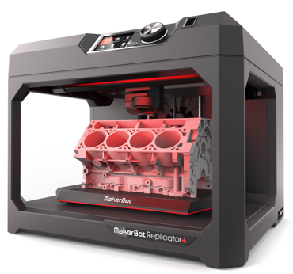

Outer Shell – This can be 3d printed out of plastic inexpensively and scaled to ensure the rest of the components fit inside the body of the agent.

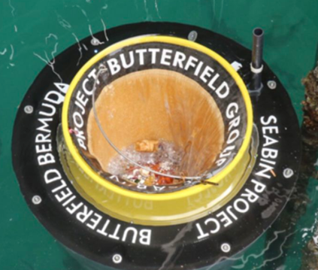Net – Similar to the SeaBin these agents will be using a net to catch all the waste it is sucking up. The benefit of a net is that it can be changed out for different purposes such as catching oil.

The net used by the agents will be 40cm long and 40cm wide, smaller than the 50x50cm net used by the sea bin.

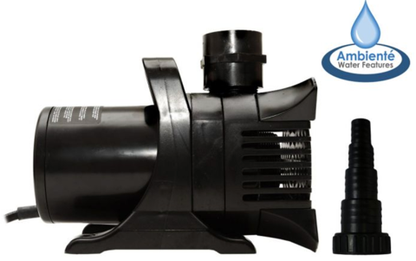Ambientè 20,000 LHP Water Pump – The sea bin uses a 25,000 LPH water pump for their 50x50 net. As the net used is 1/5th smaller it is appropriate to have a less powerful pump to pump out the water. The water outputs can also be used as thrusters to move the agent forward.

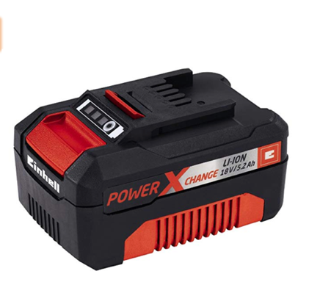

Batteries – 2x Einhell 5.2Ah battery packs is more than enough to power the water pump and any electronics on the agent for 2 hours. The battery dimensions are 8 x 8 x 16cm.

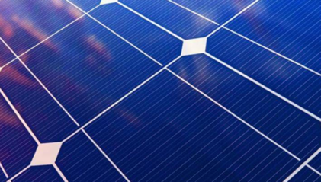

Solar Panels – To recharge the battery custom cut solar panels will have to be placed on top of the agent. It is unclear now how long it will take to fully recharge the batteries.

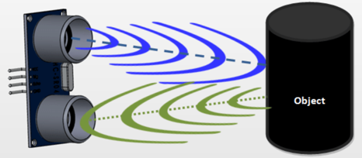Sonar Sensors – Used to detect objects in front of the agent by sending out ultrasonic sound and calculating the time it takes for the sound to bounce back, if it does at all to calculate the distance to the object. Will be used for waste detection and obstacle avoiding.

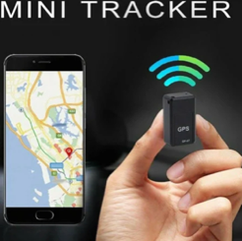

Tracker - Small inexpensive tracker used to track the agents

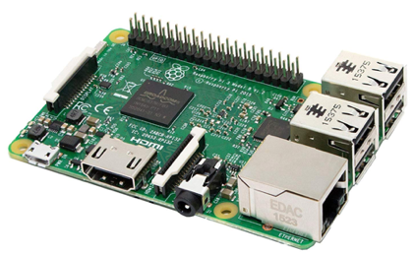Raspberry pi – Small computer to run and control everything going on with the agent

3.2 Agents Initial Design

Using the requirements devised in the research section of the project, an initial design for the agent was created. This design will first be tested on NetLogo to see how all the features would function then revised at the end of testing.

Similar artificial intelligence is already being used worldwide in the form of hoovers or lawnmowers. For example, the irobot Roomba (Irobot.co.uk, 2019) is an autonomous vacuum cleaner which uses sensors to smartly move around the house avoiding objects while vacuuming the floor. The Roomba also has a version with the addition of automatic disposal. When the agent returns to its charging point it is automatically emptied out in a bigger disposable bag. (Irobot, 2018).

A similar design to the Roomba adapted to be aquatic would be adequate in all environments. The design of the Roomba is very efficient due to its small size; it easily avoids obstacles and fits into small spaces. Similar to the Roomba, the agent design for this project is going to be fairly small. This is so the agents can be used in small water environments and be agile. The agent design will also include a storage area to hold bigger volumes of waste, so that the agent doesn’t have to return to shore often and can be left out at sea for longer time intervals.

The components will need to be taken into consideration when designing the agent as they all have to fit inside the water proof shell.

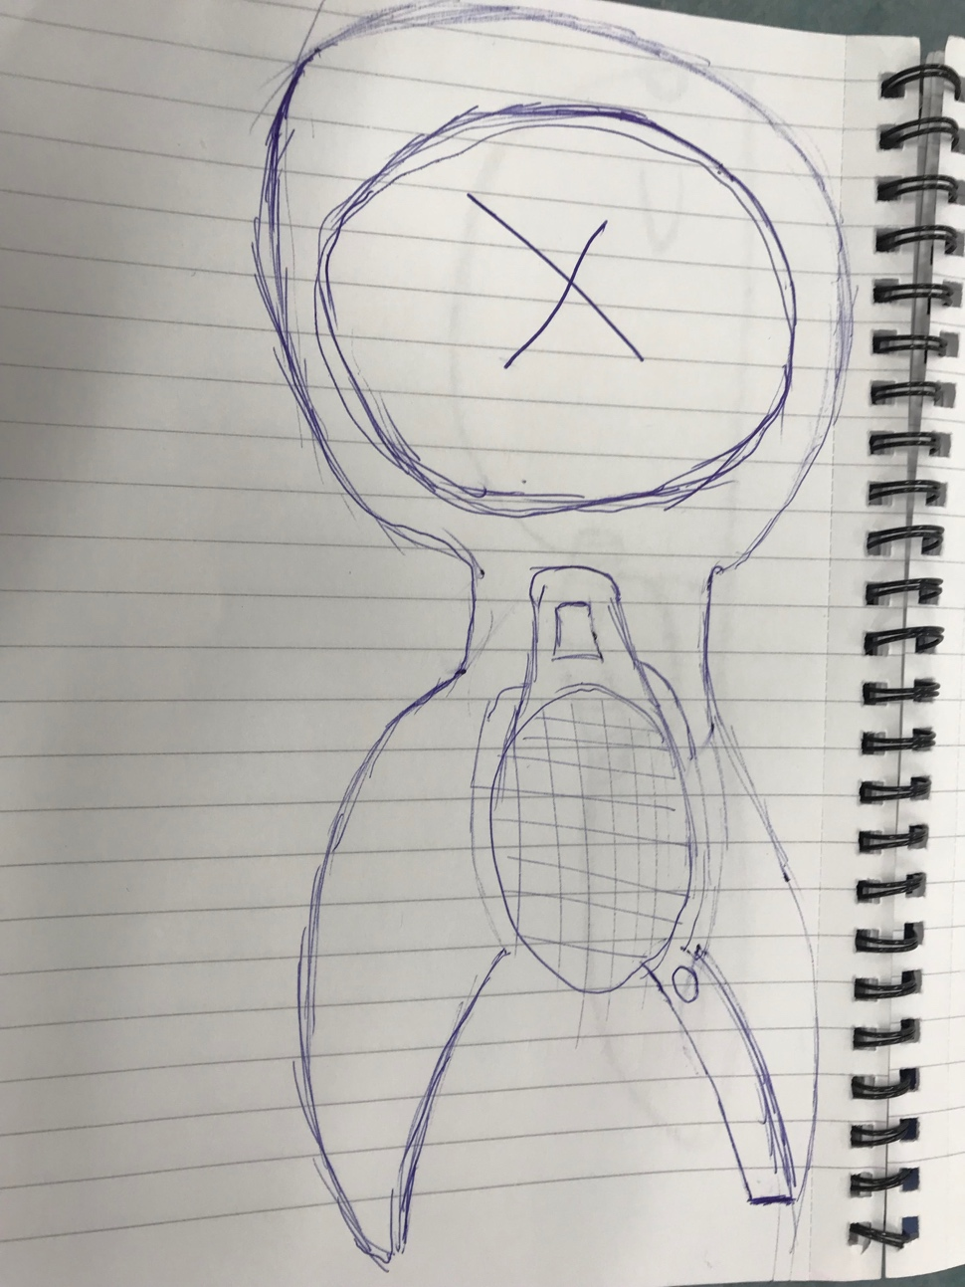**Figure 1 - Aerial view**

1.Sonar Sensors

2.Catch bag

5.Solar Panels

3.Hinge Mechanism

4.Storage Area

**Figure 2 - Side View**

6.Water Pump

7.Water Jets

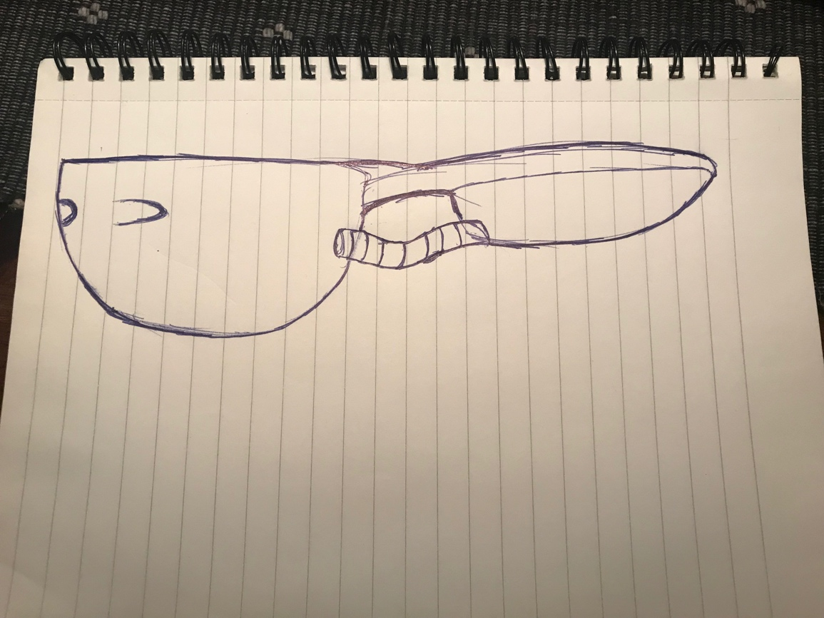

8.Water Pipe

9.Batteries

**3D Render of Design**

To better visualise the agent, a 3D model was made using Solidworks (CCSL SOLIDWORKS Reseller, 2019). The tutorial videos were used to learn how to utilize Solidworks and make models (Solidworks, 2009)

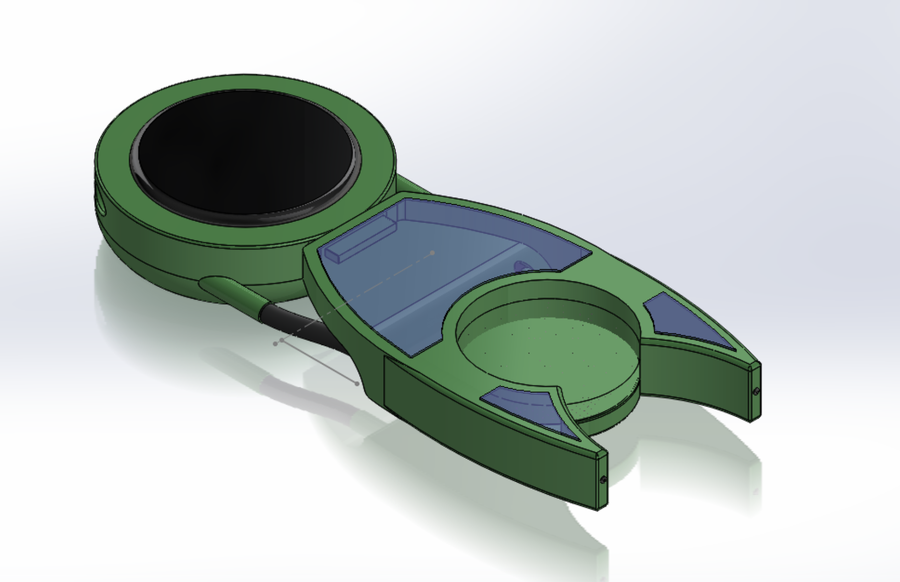

130 cm

60 cm

40 cm

Unfortunately, solidworks uses a trial and was able to get a limited number of pictures before it expired.

3.3 Feature Analysis

1. **Ultrasonic Sensors** – These sensors are used to detect objects in the water. They work by sending out a sound at a frequency too high for humans to hear and wait for the sound to be reflected back, calculating the distance based on the time required for it to come back.
2. **Catch bag** – Interchangeable net attached to the bin similar to what was seen in SeaBin. The nets can have unique purposes such as oil catching, microfibers catching or normal pollution catching.
3. **Hinge Mechanism** – The hinge mechanism can be used to the waste collected in the catch bag to the storage area to allow the agent to carry more pollution without having to return to be emptied.
4. **Storage Area** – This is where the pollution collected in the catch bag will be stored
5. **Solar Panels** – Solar Panels will be used to charge the batteries to allow the agent to run.
6. **Water Pump** – Similar to the SeaBin the water pump will pump out the water sucked in to the agent.
7. **Water Jets** – The water pumped out of the agent will come out of the water jets. This also serves as a way to propel the agent through the water. There will be numerous water jets to decide the direction of the agent.
8. **Water Pipe** – Way for the water to get from the pump to the Jets
9. **Batteries** – Allow all appliances to run and are charged by the solar panels.

**4.0 Implementation**

In order to test and visualise the product a NetLogo simulation was developed by using the agents initial requirements to model the features of the simulation. NetLogo does not provide the complexities of a real environment but does offer great testing capabilities. This section will focus on documenting the implementation of the simulation, how it was made, and the difficulties faced while making it.

4.1 NetLogo Simulation

In NetLogo, agents are called “turtles”, so the first step of designing the simulation was to design the agents in the Turtle Shape Editor which is a built-in function of NetLogo. For my simulation I would need the main water cleaning agents, waste in the water and avoidable obstacles such as rocks.

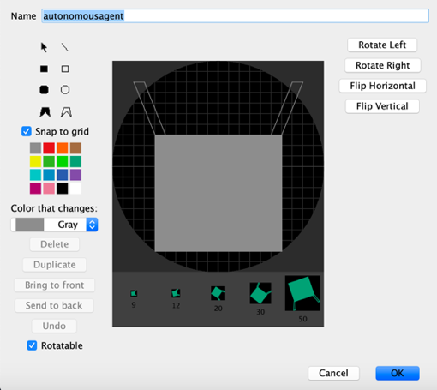

The goal was to have the main agent of the simulation resemble the initial sketch. The design includes the claw design and is suitable for what we need it to do as part of the simulation.

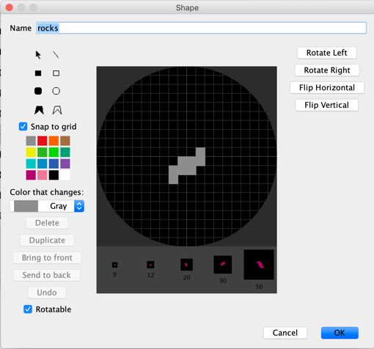

Obstacles were designed as simple rocks. The scope of rocks is to show an agents capabilities of avoiding obstacles that will be floating around in real world environments, whether it is a bottle too big to be sucked up or a rock in the water, the agent must avoid it.

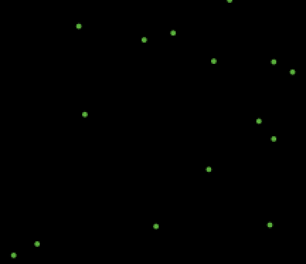

Lastly, the waste in the environment will be represented by randomly placed small green dots in the environment.

In order to implement the above features into the simulation they were declared as individual turtles as shown in Figure 1 of Appendix B

The next step was to allow the agents to “see” the rocks and the waste. The plan for the real agent is to include sonar sensors in the front to allow it to detect waste and obstacles in the sensors range. For the simulation to allowing the agents to see objects was a difficult task. This was because we cannot provide the agents with global knowledge. Global knowledge means knowledge that is beyond local and indigenous and thus coding the agents as if they knew where the others are would not be realistic. This feature was implemented by referencing back to the Cognitive and Social Robotics module (6COM0141, 2018) where we learned how to use a vision cone to allow agents to see ahead of them. This is realistic and mimics how a sensor would be used to allow the agents to see.

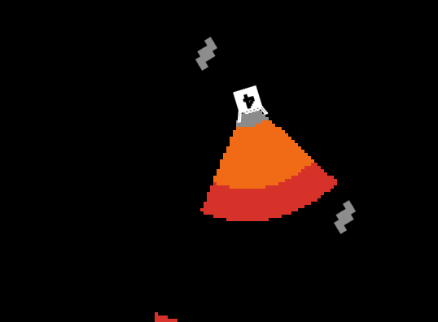

Unlike a sonar sensor the vision cone does not take into account distance, and in order to mimic distance, 3 vision cones were used on top of each other so that each can be used for different purposes. The above is shown in the screenshot aside. The length of these can be edited by sliders and the size of their angle are also controlled by a slider as seen below.

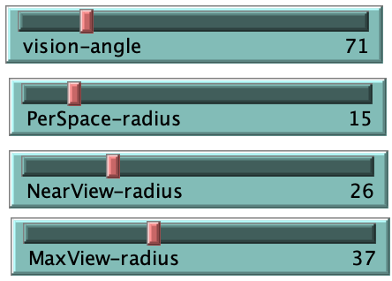Angle of the vision cones. Increasing it will increase their angle and area covered

Grey vision cone slider, increasing it will increase the length of the grey vision cone.

Orange vision cone slider.

Red vision cone slider.

The grey vision cone is set to act as the vacuum zone and when waste gets into it will be picked up by the agent. This is visualised by the waste being killed and the agent changing shape to symbolise picking it up. The code for this can be found in Figure 2 of Appendix B

The orange area will be used to detect waste. If the waste will be inside the orange vision cone the agent will recognise it and face itself towards it to pick it up. This can be seen in Figure 3 of Appendix B

The red area will be used for obstacle detection. It will also be used to implement swarm movement. Once an obstacle will be detected in the red vision cone, the agent detecting will turn away to avoid collision. This can be seen in Figure 4 of Appendix B

As discussed in the introduction alone a single agent would not make a huge difference, but a swarm of them would. For this to be possible agents must follow swarm behavioural rules. In order for the rules to be implemented, the same vision cones must be used.

These being:

* If an agent sees another agent in the grey vision cone the agent will turn away from it and jump a number of blocks away. The value for the number of blocks is set by a slider named EscapeJump.

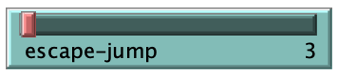

* Similarly, if an agent sees another agent in the red vision cone the agent will turn towards it and jump towards it by a number of blocks. The number of blocks is determined by a slider named JoiningJump shown in

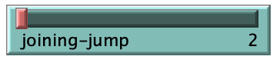

* If an agent sees another agent in the orange vision cone the agent just performs its basic movements and turns left, then right randomly by a random value between 1 and 20.

Agents will aim to follow other agents in their orange vision cone and will jump towards another agent in their red vision cone. Similarly, an agent will jump away from an agent that is too close in their grey vision cone in order to avoid collision. The code for the swarming behaviour can be seen in Figure 5 of Appendix B.

Subsequently, now that the agents can see the waste, they must be able to pick it up. In a real environment this is done by the water falling through the net leaving behind any pollution into the net. Simulating this effect was the next difficult task as NetLogos features don’t include anything to resemble items being picked up. Looking through the dozens of models included in the NetLogo model library. The Termite model featured the agents “picking up” scattered wood by making the wood turn the same colour as the background when a termite was on top of it and changing the colour of the termite. The termite then drops the wood on the closest background patch when it steps on a colour other than the background. This visualises the agent dropping the object. The concept behind the termite model inspired the current picking up feature of this simulation

To mimic the feature of picking items up a counter was added which would increment every time a piece of waste was inside the grey vision angle. This can be seen in Figure 2 of Appendix B

The waste was thereafter killed to remove it from the environment and mimic the action of the agent picking it up. To visualise this, a different model was made for the agents with different amount of waste picked up. The models are respective to the counter and can be seen below.

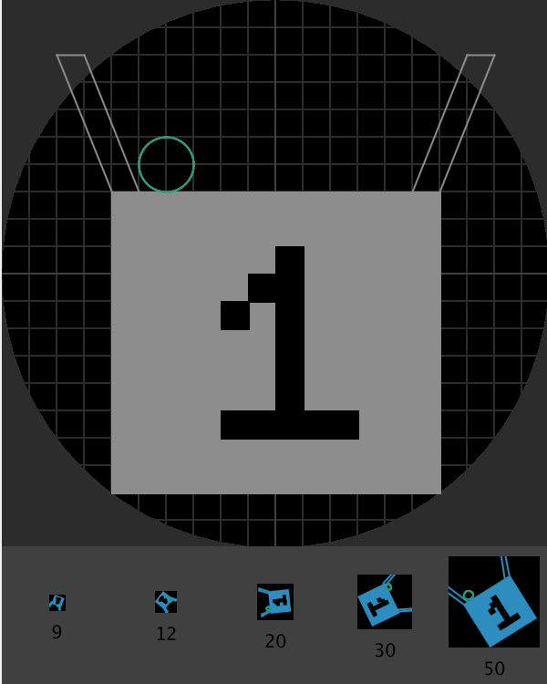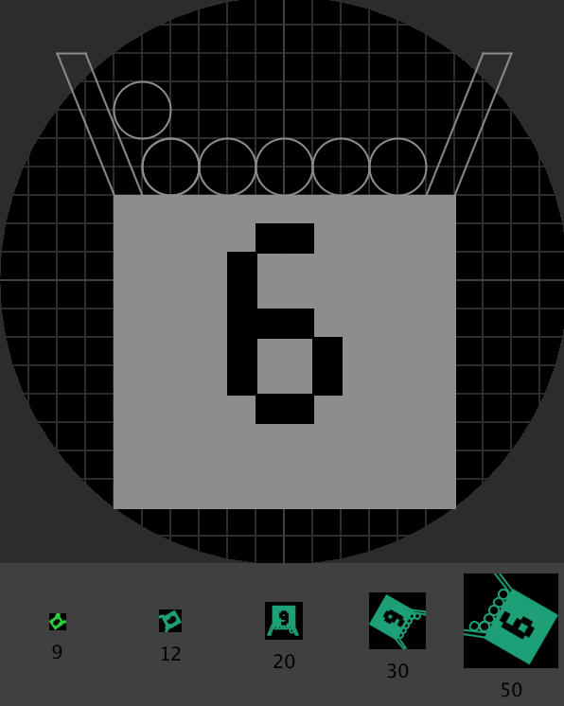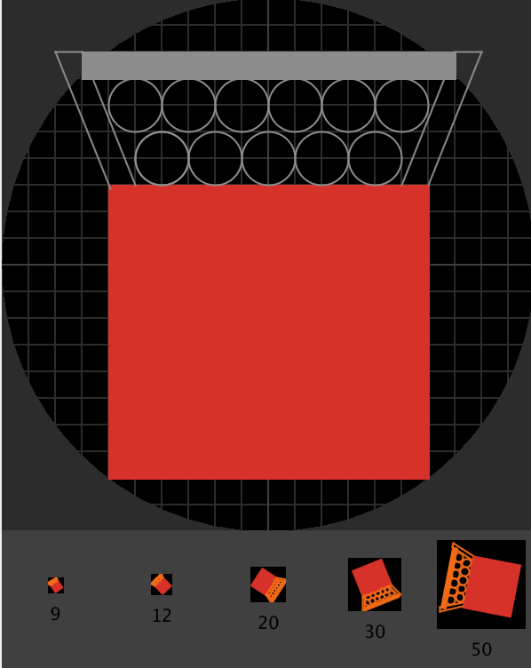

Once the agent picks up 11 pieces of waste it turns red and stops picking up waste. This is done by changing a variable called state. When state is on “gather” the agent picks up waste. Once the agent picks up 11 pieces of waste the agent is considered full, turns red and stops picking up waste. The code for this part can be seen in Figure 2 of Appendix B

Next, a battery function was added. In reality the agents will be powered by batteries which will be recharged by solar power. In the simulation battery is a variable allocated to the agents that decreases by 1 every tick. Once the value of the battery reaches below 10, the agent stops, and the battery starts recharging. To visualise this the agent turns yellow. Once the battery is recharged to an adequate level, the agents resume moving as normal. The

code for the battery function can be seen in Figure 6 of Appendix B

Finally, the movement of the agents was configured into 2 settings. A logistic movement and random movement. This idea was inspired by the artificial life coursework 2 (6COM1041, 2019). The purpose for the different moving is to be able to find the most efficient way between a stochastic movement and random movement and which one resulted in faster cleaning times. The equation for the logistic movement was taken from Lecture 5 of the artificial life module (6COM1041, 2019) and was scaled to fit our environment. The code for the 2 types of movement can be found in Figure 7 of Appendix B. The agents movement can be changed from Logistic to random by the flick of the switch shown below and the C value in the logistic equation can also be changed here although for best result it should stay at 4.0.

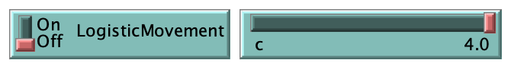

**5.0 Testing**

To cover all aspects of the simulation thoroughly, it will be put against testing criteria in order to find any bugs and possible improvements that can be made. This section will cover all tests done, any problems found, and the solution applied as well as any changes to the code.

5.1 Code Testing

How much waste can an agent picked up and what happens when it full?

Test Criteria: Running a single agent 10 times and drawing an overall answer based on it.

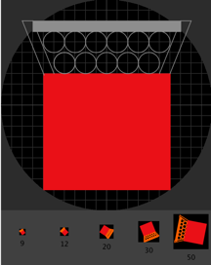The test concluded that the agent would roam the environment and would collect waste until it reached 11 pieces of waste. At said point the agent would turn red to symbolise it was full and stop.

Ideally an agent should not stop when full but should instead take the waste collected somewhere. The 2 options would be to either take it to shore or have some sort of container floating in the water alongside the agents that the agents could take the waste to. A container would be more advantageous because it has the option to be deployed far out at sea in comparison to having the agents drop the waste on the shore. The container could also double down as a storage and charging facility for the agents.

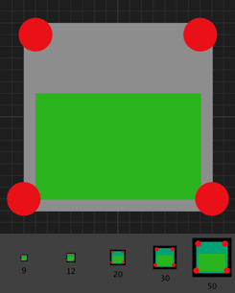To add a container, it was first declared as a separate turtle. This can be seen in Figure 10 of Appendix B.

Secondly, a model was designed for it using the Turtle editor so it can stand out from the rest of the agents. The container can be added by a switch and it’s starting location can be determined by 2 sliders. The starting location of the agents will now be from the container to visualise the container being a carrying point for them. If a container is not added, the starting location will be random.

Now when full, the agents will carry on moving without picking up more waste and will drop off the waste collected next time it crosses paths with the container.

It now also means that for the real-life design, it no longer needs to include extra storage space as part of the agents, making them smaller, faster and more efficient.

Updated design:

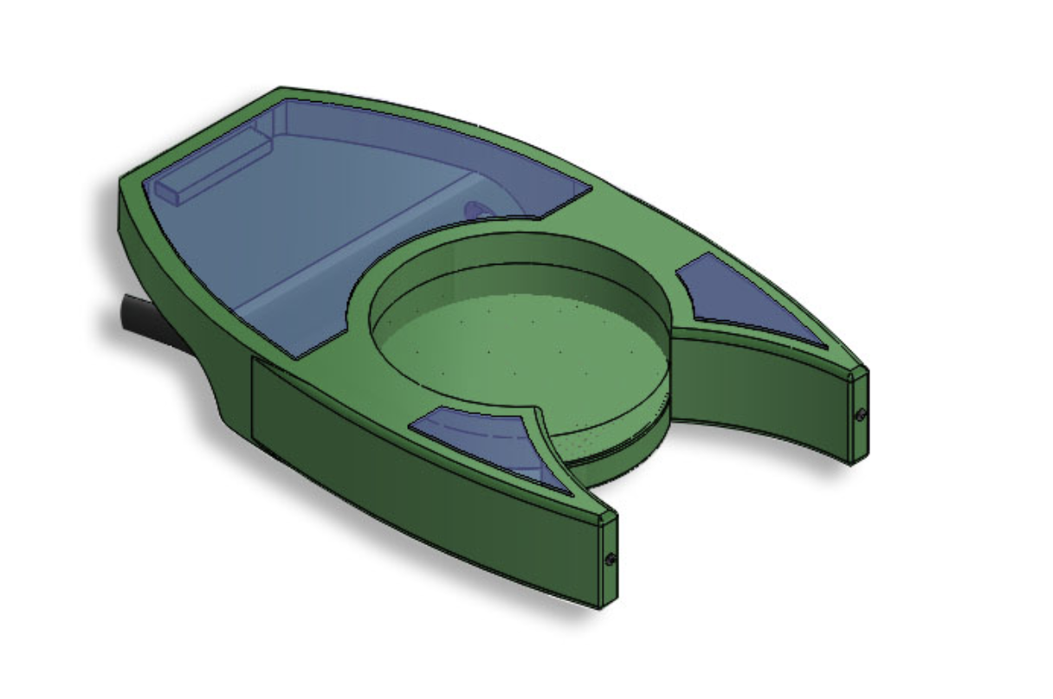

In a large environment example: at sea how will the agents stay within a reasonable distance and get lost at sea?

At the moment there is nothing restricting the agents from staying within a certain area apart from the borders of the world. The requirements state that the agents must be usable in all environments. However, at the moment they would not currently be very viable as they can roam randomly and get lost at sea.

In order to resolve the issue, a switch and slider was added which offered the possibility of adding a strict distance range to the agents.

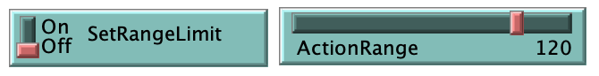

Once the agent would reach the limit of this range, they would take a 180 degree turn into the green zone. This range is centred on the container agent meaning the agents will swarm continuously around the container inside the range given.

The advantages of this are that the container itself could be moved to an area with high waste concentration and the agents would swarm around the container. This would require the container to have some sort of global knowledge. This could either be satellite or a person over watching the space. A person over watching the space could use a remote control to control the main container and move it in the desirable position. A satellite will benefit as it can warn the system of bad weathers so all the agents go back to the container so they do not get damaged.

NetLogo offers HubNet which adds a new dimension to NetLogo by allowing simulations to run not just according to rules, but by direct human participation. (NetLogo, 2019). With this feature it is possible to make a remote control to control the main container. The development (seen below) was fairly straight forward and the Container agent responds to the outside controls.

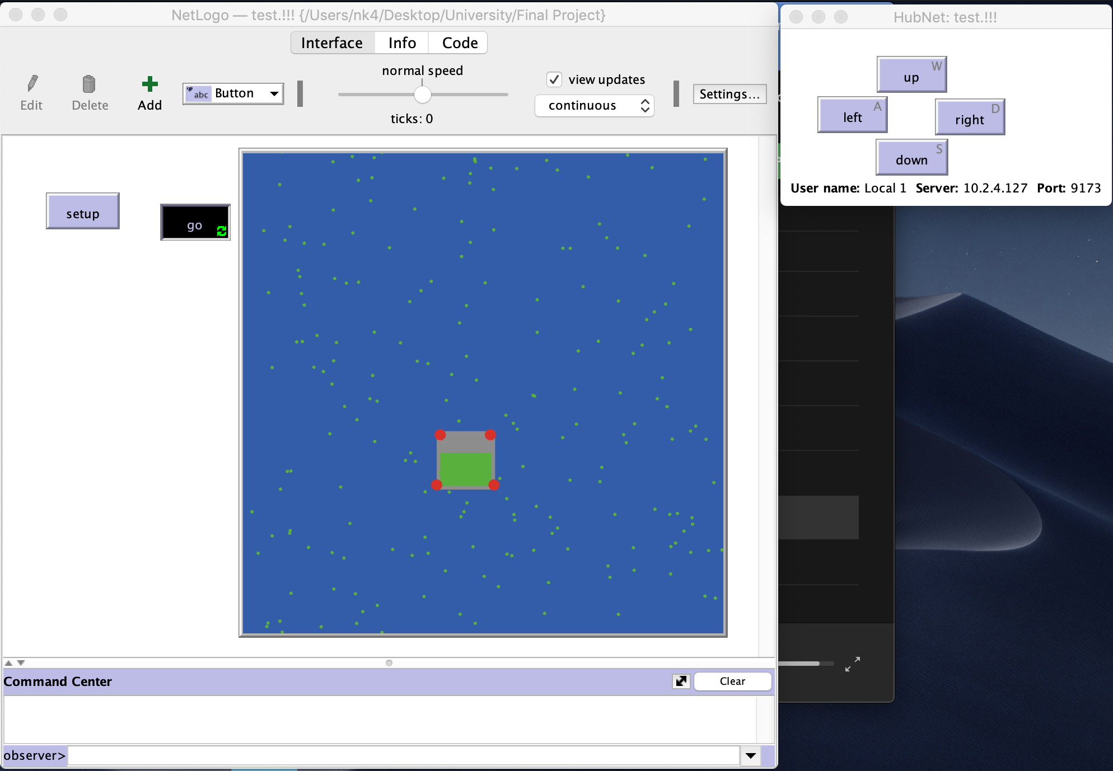

This feature implemented in the main simulation would cause the simulation to run extremely slowly and as a result was made in a separate file. Assuming everything would works as intended, moving the container in a different area will have the agents follow the agent into that area if the range feature was turned on. The full code can be seen in Figure 2 of Appendix C

What happens when an agent detects waste outside of its allowed range?

As of now, if an agent detects waste outside of its allowed range, it will ignore the range and pick up the rubbish. After the waste is picked up the agent will head back inside of the range. This is due to the instructions of facing the waste overrides that of the range.

How can we know the logistic movement is indeed logistic?

In order to test the logistic movement a plot graph of the last angle vs the new angle was added to the NetLogo simulation. A logistic movement should result in a hyperbolic raising from 0 to 1 back to 0 when implemented correctly. The code of the graph added can be seen in Figure 8 of Appendix B.

Result:

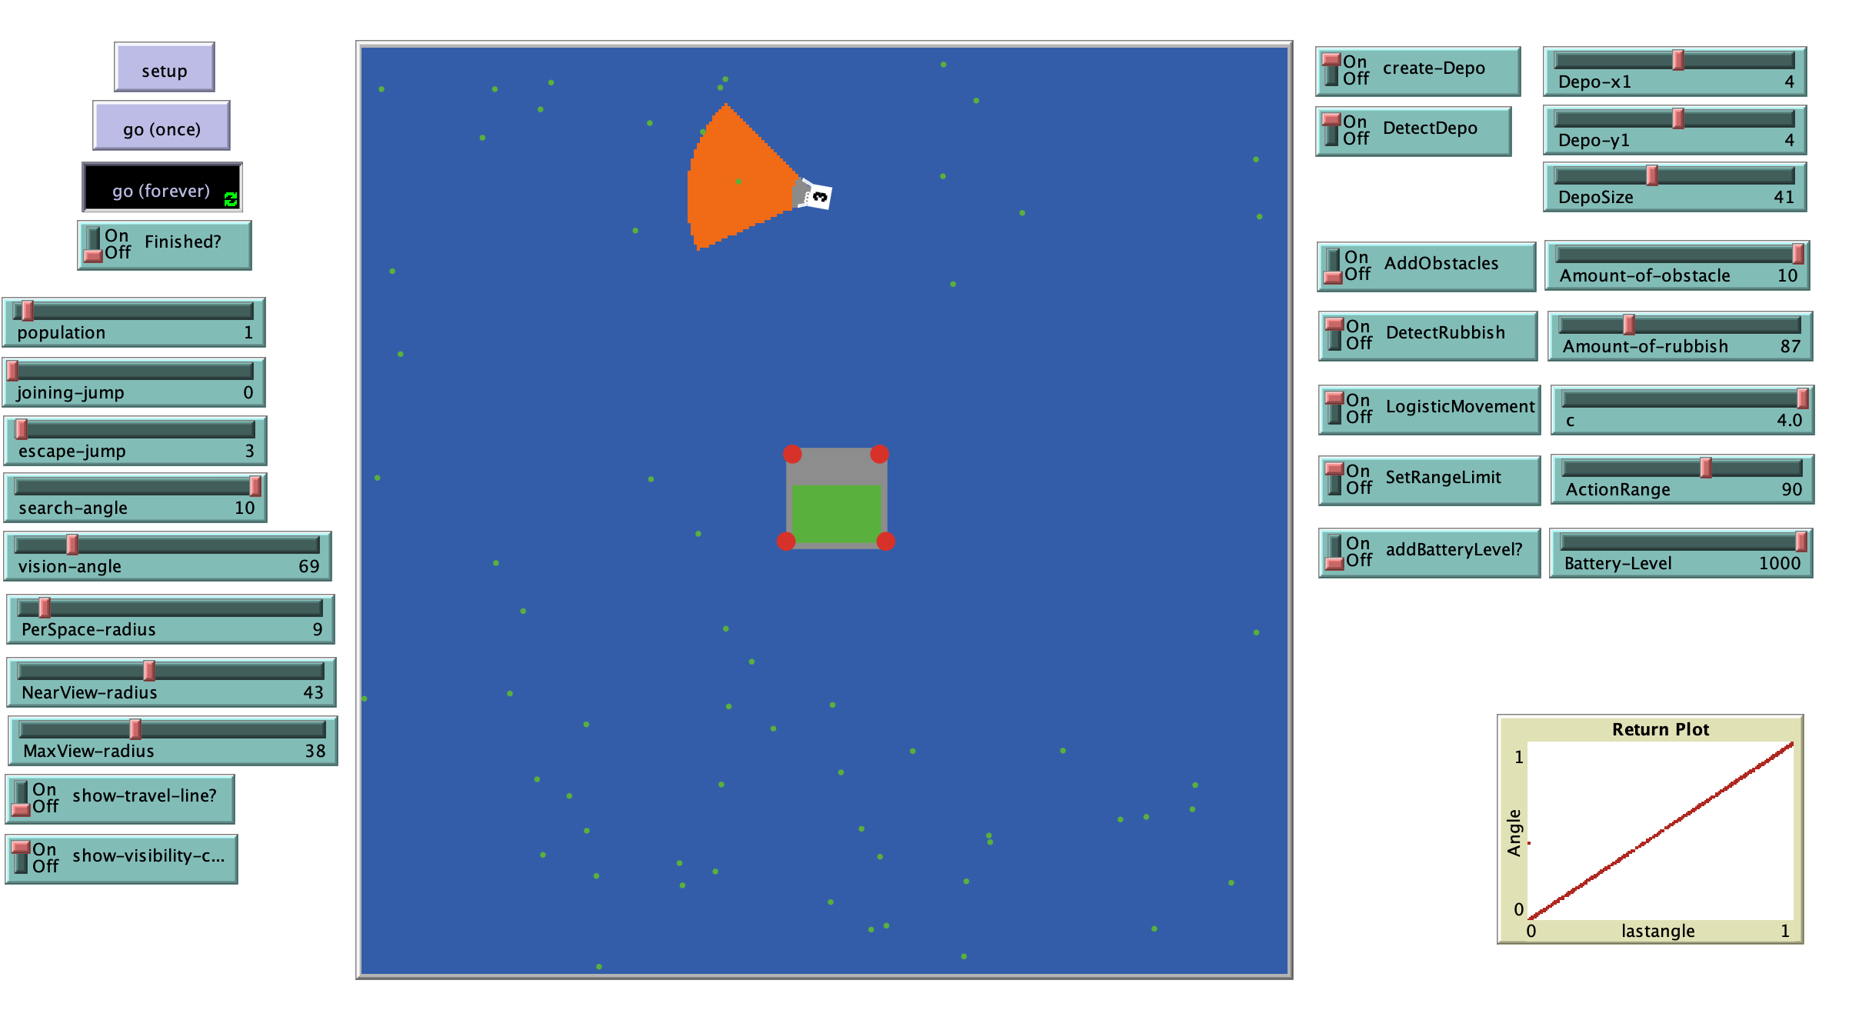

From the result above we can see that the plot (bottom right) shows a straight line meaning that the logistic movement is implemented incorrectly. After checking over the code shown in figure 7 of Appendix B, the problem was the location of the “set lastangle angle” line. The last angle should be set before the equation is calculated whereas here it is calculated after.

The attempted solution can be seen in Figure 9 of Appendix B.

The result plot of the solution shows the expected result, meaning the agent now moves logistically.

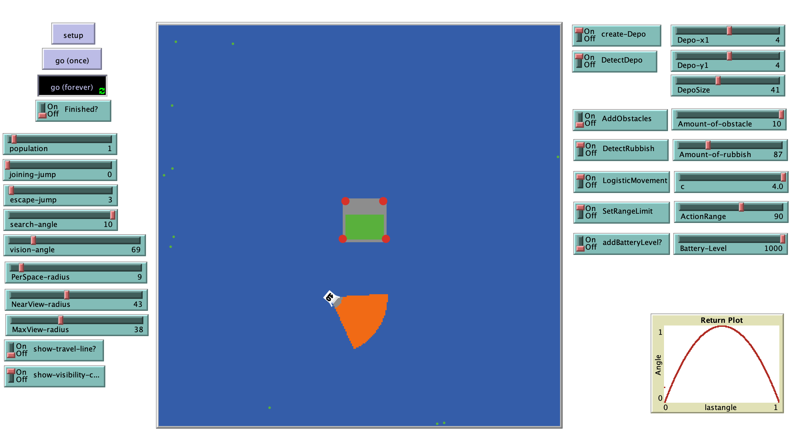

Do the agents avoid other agents and obstacles correctly?

Agents avoid obstacles and agents correctly as long as their respective vision cones are used. Sometimes it is possible that agents may phase through one another when too close together the rules may sometimes result in an agent jumping on top of another agent.

How do the agents know the difference between waste and obstacles?

In the simulation agents are coded with global knowledge of what is waste and what is an obstacle as there is no other way of doing it. In real life an agent would scan all objects detected and determine whether they are obstacles or waste by their size. This is the same concept used in Coursework 2 of Constructive Artificial Intelligence (6COM1035, 2019). Here thymio robots were programmed to distinguish between obstacles(boxes) and waste (cups) to push them out of the circle. A video for this can be found at: <https://1drv.ms/f/s!AtfCoRJMS8yPghEjaBT9AblKvywG>

It is also possible to train the agent to detect waste by pictures. This would however require camera and more complex coding. However, this shows that it won’t be a problem to get an agent to distinguish between obstacles and waste in a real environment.

The full code for the simulation can be found in Figure 1 of Appendix C.

The full code for the Depo controller simulation can be found in Figure 2 of Appendix C.

5.2 Parameter Testing

In order to maximise the efficiency of the agents, ideal parameters values must be used such as the best turning speed, best c value in logistic movement, best container position etc. NetLogo is perfect for this as values can be changed and tested easily using a feature called BehaviourSpace. BehaviourSpace allows the possibility of performing experiments with models. It runs the same model many times, systematically carrying the model’s settings and recording the result of each run in an excel file. It lets the user explore the model’s “space” of possible behaviours and determine which combinations of settings cause the behaviours of interest. (NetLogo, 2019)

Firstly, the movement parameters will be tested to see the most efficient way of running the agent, between random and logistic walk. BehaviourSpace was used by going through tools -> BehaviourSpace to speed up the process. The experiment was setup as shown below:

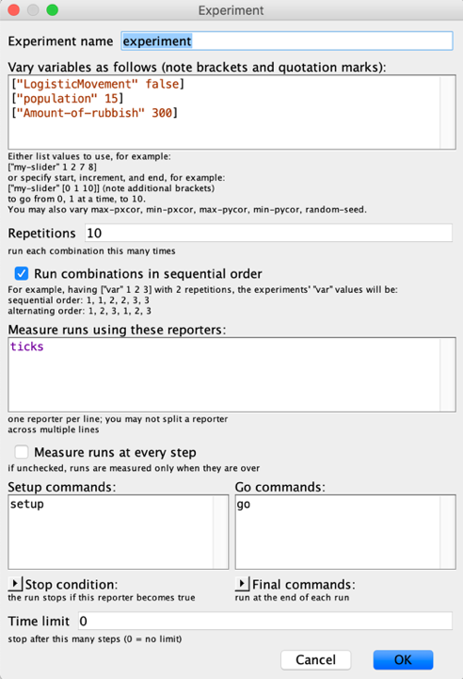

The variables being tested here include the population and LogisticMovement. For increased precision each experiment is repeated 10 times. In the case of this experiment we are measuring the number of ticks it takes to clean 300 pieces of waste. In order to do this the switch “StopWhenFinished” must be turned on.

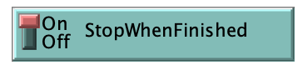

The independent variables here are the population and LogisticMovement which will be changed in turns. For each population number there will be two sets of results; one for random movement and one for logistic movement. The results will be collected in an excel file where the average will be calculated and used to create a result graph.

The result table can be seen in Figure 11 of Appendix B

Here is a scatter graph of the report which include 95% intervals and line equation. We can see that there is a reliable connection between number of agents and ticks taken to clean the environment. The y equation can be used to predict how fast an environment can be cleaned knowing the number of agents and it is reliable due to the strong correlation between the values.

Below the same data was plotted in a bar chart for further analysis of the significance of movement.

This graph clearly shows the confidence intervals overlap each other between logistic and random movement in all cases. This means that type of movement may not be significant. To further test the significance of the type of movement the P-value was worked out.

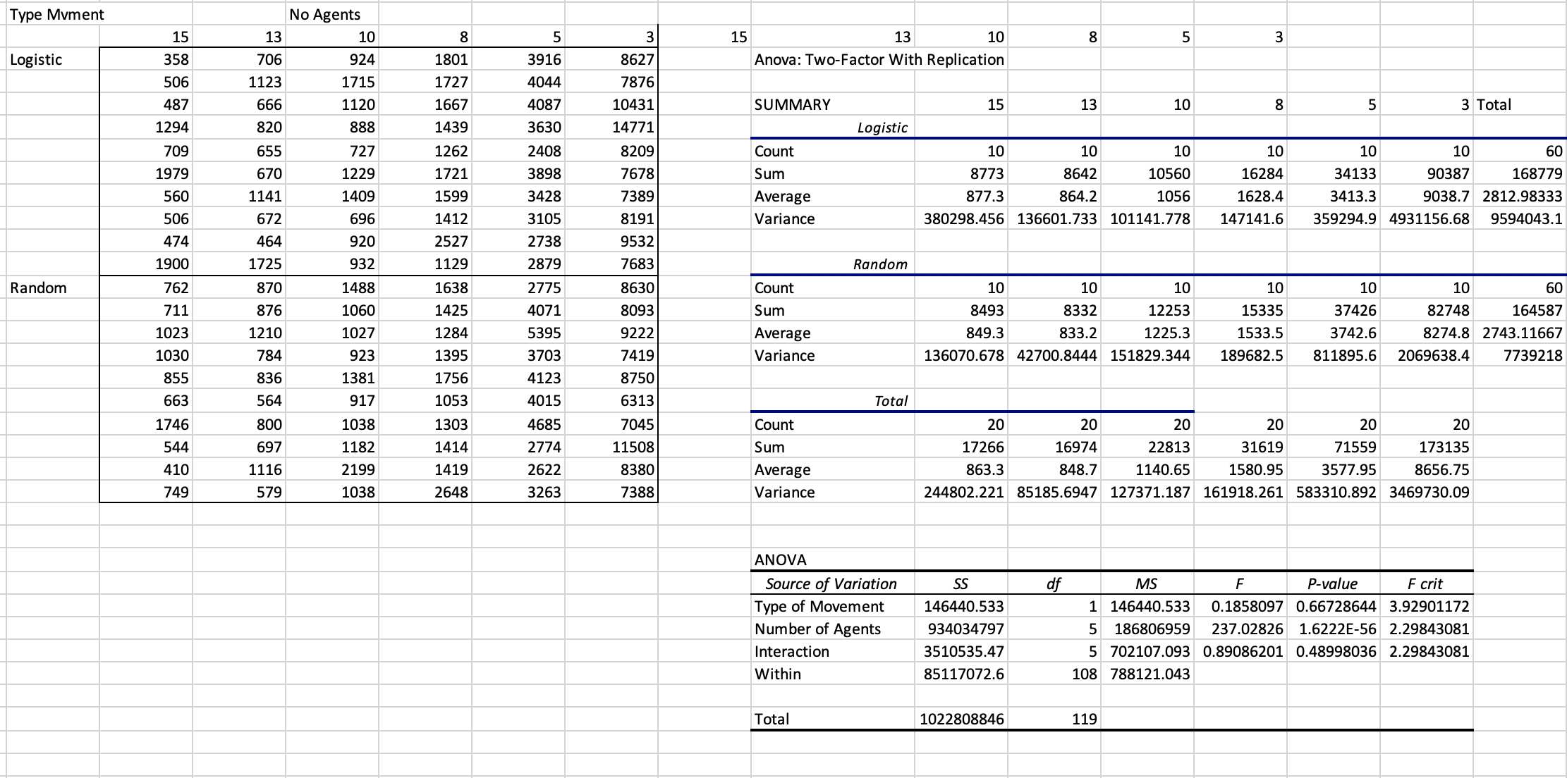

The small P-value for Type of Movement solidifies the suggestion that type of movement is not significant!

Secondly, different values for the search-angle will be tested. In this case the dependent values are the population, movement and amount of waste, and the independent value is the search-angle. Since both random and logistic movement makes use of the search-angle to determine their turning angle, tests for both types of movements will be conducted. The full test results can be seen in Figure 12 of Appendix B

The results show that there is no particular trend for the search-angle. The results suggest that the higher the search-angle the lower the number of ticks that is needed to clean an environment. This however is very much based on the size of the environment, therefor a ideal value depends on the environment. It is also possible that a search-angle even higher than 10 may result in better results. Because of this the search-angle maximum value was changed to 360 to include a full turn. This will come in useful for testing purposes.

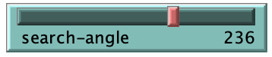

Thirdly, the value of c used for logistic movement will be tested. The dependent values are the population, movement, amount of waste and the search angle. The independent value is the c value. The c value is a 2 decimal place value but for timing reasons it will be tested for the values of 4, 3, 2 and 1. The full result table can be seen in Figure 13 of Appendix B

The results show that c value 3 had on average the fastest time needed to clean out all waste in the environment. There could be a better value in the decimal places however finding it without the use of a genetic algorithm would be time consuming. The overlap of the 95% confidence intervals suggest that the C value is not significant. The changes to the C value is very dependent on search-angle also as search-angle is used in calculating the turn range. Further testing needs to be done against the C value to ensure it is significant or not

Outside the parameters there are options which have drastic effect on the time it takes for the agents to collect all the waste. These options may or may not be realistic in a real environment and may be turned off. For example:

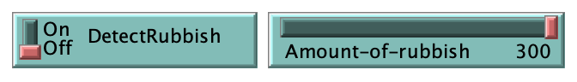

When on this switch allows agents to see waste inside their vision cone and change their direction to increase its chances of sucking it up. For this agent the switch can be turned on since it uses sensors to detect waste.

A test was done where 10 agents had to collect 300 pieces of waste. The only independent variable was the DetectRubbish switch. The results can be seen below, and the full table can be found in Figure 14 of Appendix B

The results show the agents ability to see waste is highly valuable as the average taken to collect the same amount of waste is less than 1/3 than that of the agents that cannot detect waste.

(This testing stage was completed with help from my Supervisor)

6.0 Discussion and Evaluation

In this section we will be discussing and evaluating the project thus far outlining the work done so far, future work to be done and changes I would make to the project.

6.1 Discussion

During this project already existing concepts of artificial intelligence such as Roomba hoovers were explored. I found out that artificial intelligence, applied in the right way can become a real solution to some of the biggest problems worldwide. Artificial intelligence doesn’t have to be expensive or difficult and these agents show that by following basic rules encouraging results can be accomplished. The simulation shows that the agents can function well as a swarm in a basic environment and provide a probable solution to water pollution. The simulation can be used for testing in order to find optimal parameters, however this is time consuming. The agents can further be optimised by finding the absolute most ideal parameter values to increase the efficiency of the agents using a genetic algorithm. A genetic algorithm repeatedly modifies a population of individual solutions to find optimal results. I hope that in the future I will secure the needs to fully develop the agents and test it in a real complex environment as I believe it has huge potential to become a viable solution to water pollution as long as it can run of green energy. I further hope that using the container I can further increase the amount of green energy used by harvesting wave and further solar energy.

Further testing done against the movement of the agent showed that the between logistic and random movement there was not a significance difference in the time it took to clean the environment. This may be down to the small search-angle of 10 which means that the agent deviates very lightly from a straight-line path. The search-angle will be increased, to possibly cover a while 360 degree turn and further testing will need to be carried out. The logistic movement at the moment uses 2 separate logistic systems for a left and right turn, as seen in Figure 7 of Appendix B. In the future I hope to test a movement system of only 1 logistic system that alternates between left and right turns to see if any difference is made to the significance of the movement.

6.2 Evaluation

The development of this project, as a whole turned out positive. From the research done on other projects and the public criticism they have attracted it is confident to say that the requirements chosen are sensible and likable to the public. The final design reached is perfectly adequate to fulfil the proposed requirements and will be efficient in a real environment due to the small dimensions. Further the simulation implemented showcases the agents capabilities real well and can be meaningfully used for testing purposes. As there are many parameters deciding the movement of the agent which has drastic impacts on the efficiency of the agent, it is very convenient to have a simulated environment where the user can adjust the parameters as he wishes in order to visualise the result. The simulation itself can be used by others as a testing tool due to its versatility and easy to change parameters. It can also be easily modified to fit extensive needs. However, the simulation only covers a very basic water environment not taking into account real life occurrences such as waves and currents. A big change I would do to improvement the overall project would be to create a 3D simulation based on possibly a game engine that allows the possibilities of including and taking into account real life occurrences. Further future work includes the designing of the Depo agent and testing.

**7.0 Conclusion**

7.1 Final Design

Here we have the final design of the proposed agent. This design is ideal as it is small and has enough space to fit all of the components needed. The size of the agent means that it can be agile and easy to manoeuvre around a water environment.



90 cm

60 cm

40 cm

7.2 Conclusion

To conclude I believe the simulation outlines the huge potential of the water agents and their ability to clean different water environments. Due to their size and versatility they can easily be introduced to any water environment and provide results. This also means that this project is scalable and very robust as the number of agents can be increased and decreased based on the size of the environment and even if one fails, the goal will still be achieved as the agents do not depend on each other. Unlike some of the other water projects mentioned, these agents have the possibility to function using only green energy due to their ability of recharging the batteries using solar panels. As a result, these agents are inexpensive to build and inexpensive to run. Furthermore, the agents need for input is none existent meaning that the agents themselves are fully autonomous and do not need any guidance or supervision. However, the involvement of a container agent which may not be suitable for all environments means the involvement of global knowledge. Moving the container to high waste concentrated areas means either the use of a satellite or a person manoeuvring it using a remote control. Reflecting on my requirements, I consider that they have all been accomplished to a high enough standard and conclude that I achieved my goal of planning and designing an autonomous solution to water pollution.

**8.0 Bibliography**

**References:**

Le Guern, C. (2019). *Plastic Pollution*. [online] Plastic-pollution.org. Available at: http://plastic-pollution.org/ [Accessed 21 Feb. 2019].

Casson, L. (2019). *How does plastic end up in the ocean? | Greenpeace UK*. [online] Greenpeace UK. Available at: https://www.greenpeace.org.uk/plastic-end-ocean/ [Accessed 21 Feb. 2019].

Lindsay, J. (2019). *How much plastic is in the ocean? | Metro News*. [online] Metro.co.uk. Available at: https://metro.co.uk/2018/02/05/much-plastic-ocean-7287948/ [Accessed 21 Feb. 2019].

Uri Wilensky, (2019). [online] Available at: https://ccl.northwestern.edu/netlogo/ [Accessed 20 Mar. 2019].

Techferry.com (2019) Swarm Intelligence [online] Available at: <http://www.techferry.com/articles/swarm-intelligence.html> [Accessed 17 Apr.2019]

(6COM1041, 2018). Social Networks of Random and Chaotic Moving Agents [online] Available at: <https://herts.instructure.com/courses/29525/files/462510?module_item_id=386913> [Accessed 25 Apr. 2019]

(6COM1035, 2019) Constructing Autonomous Systems [online] Available at: <https://herts.instructure.com/courses/29523/assignments/14299> [Accessed 25 Apr. 2019]

NetLogo, (2019). [online] Available at: https://ccl.northwestern.edu/netlogo/hubnet.html [Accessed 25 Apr. 2019].

NetLogo, (2019). *BehavourSpace Guide*. [online] Available at: https://ccl.northwestern.edu/netlogo/docs/behaviorspace.html [Accessed 26 Apr. 2019].

6COM1041 (2019). *L5 Dynamical Systems II – Dynamics of movement*  [online] Available at: https://herts.instructure.com/courses/29525/files/292650?module_item_id=313933 [Accessed 25 Apr. 2019].

Irobot.co.uk. (2019). *Roomba Robot Vacuum | iRobot*. [online] Available at: https://www.irobot.co.uk/home-robots/vacuuming [Accessed 28 Apr. 2019].

*Irobot (2018) Roomba® i Series Clean Base™ Automatic Dirt Disposal | iRobot*. [online] Available at: https://www.youtube.com/watch?time_continue=23&v=_vNFka2TjCk [Accessed 28 Apr. 2019].

CCSL SOLIDWORKS Reseller. (2019). *CCSL SOLIDWORKS Reseller 3D CAD*. [online] Available at: https://www.ccsl-cad.co.uk/ [Accessed 29 Apr. 2019].

Solidworks, (2009). *SolidWorks Tutorial Learn SolidWorks Lesson 1 Parts*. [online] Available at: https://www.youtube.com/watch?v=dQMS8KuDGoM [Accessed 29 Apr. 2019].

**Appendix A: User Manual**

**User Manual**

**Requirements:**

NetLogo 6.0.4 or later

**Operating Systems required to run NetLogo:**

-Windows Vista, 7, 8 and 10

-Mac OS X 10.8.3 or newer

-Linux (Debian-based and Red Hat-based)

**Here you can find all information about the NetLogo Water Cleaning Agent simulation program. This user manual includes a quick start-up guide and further in-depth description of all the settings and buttons.**

**Quick Start-Up Guide**

World Features and Description

 Agent roaming the world looking for rubbish

Different agent moods:

 - Roaming the water / looking for rubbish

 -Stopped, recharging batteries, will begin roaming once batteries fully recharged

 - Stopped, full of rubbish and cannot pick up anymore

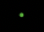 Pieces of waste in the water

 Rocks / Obstacles which are big and must be avoided by the agent

Upon loading the program in NetLogo this will be the initial screen.

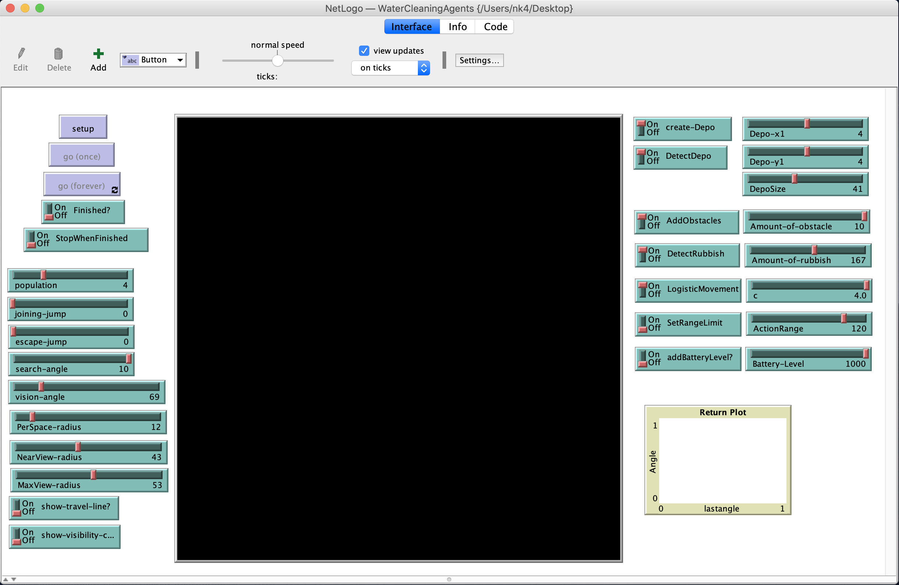

Select the number of agents, rubbish and obstacles to be loaded by using the “population” “Amount-of-rubbish” and “Amount-of-obstacles” sliders accordingly. In some cases, the switch next to the slider may need to be turned on. Next, click the “setup” button, the world should now look like the below:

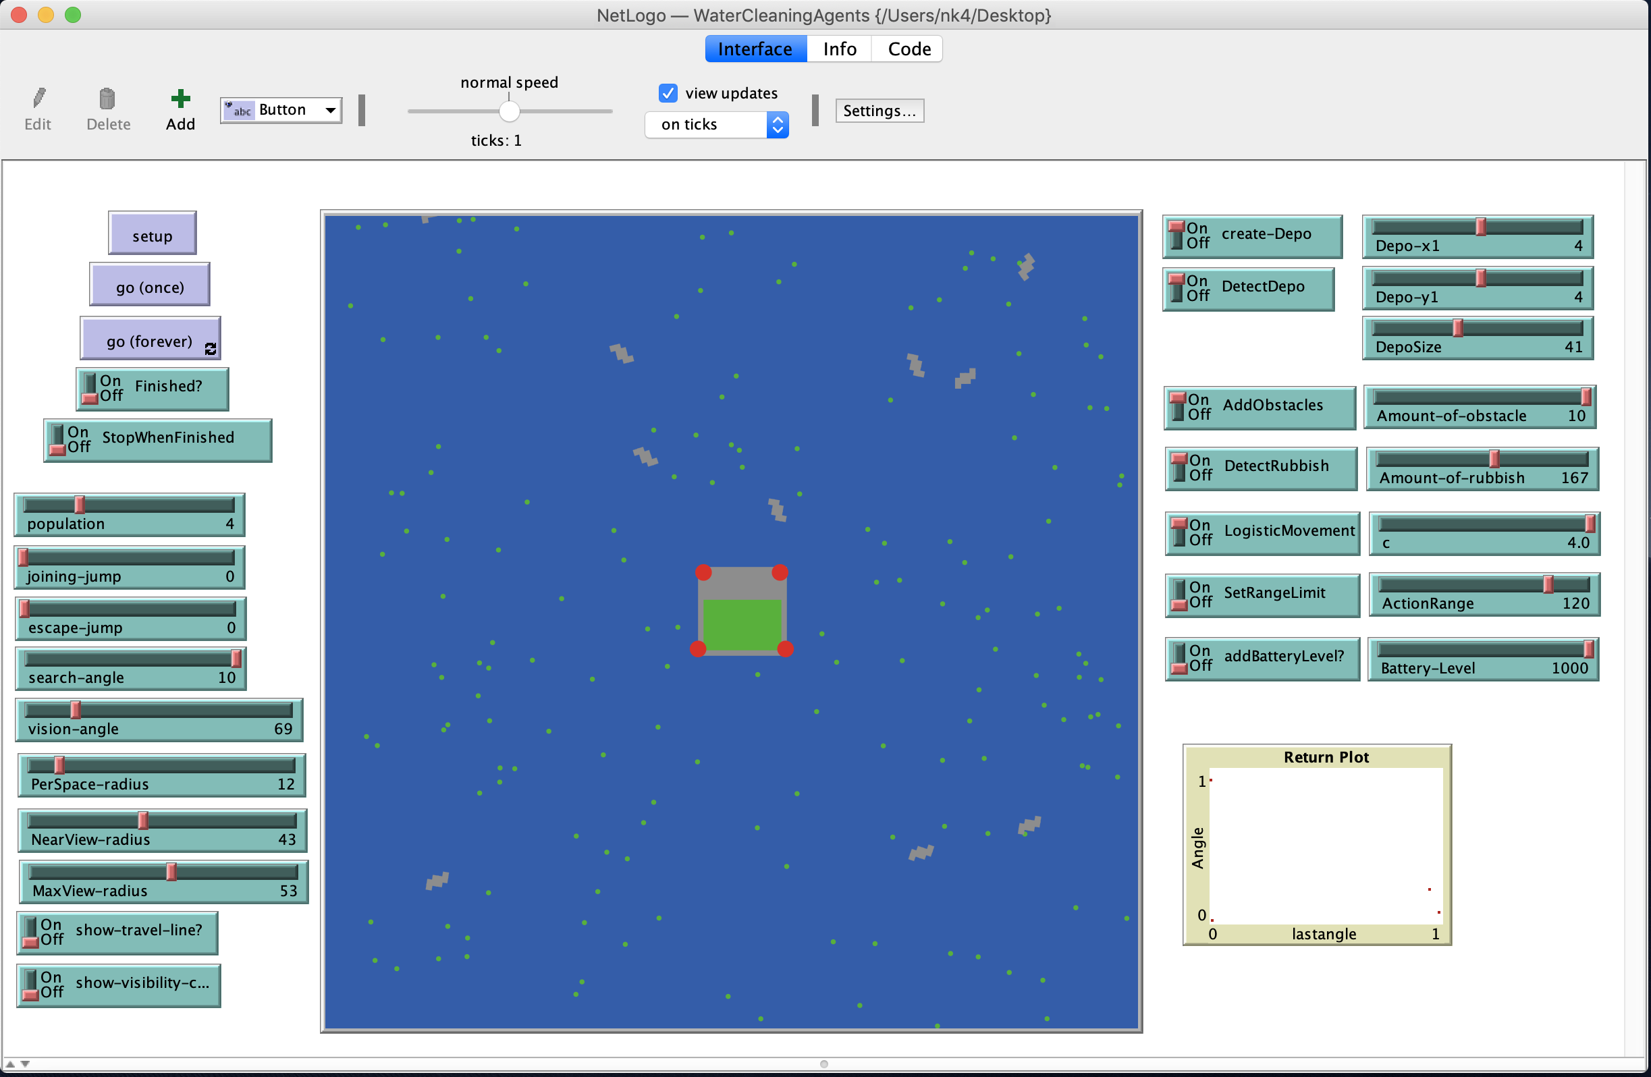

To run the simulation there are 2 go buttons, go (once) with run the simulation for 1 tick at a time and go (forever) will run the simulation forever or until told to stop. The simulation can be stopped by either turning on the “Finished?” switch which will stop the agents from running the next time they reach the container agent, or by turning on the “StopWhenFinished” switch which will stop the simulation once all the rubbish has been collected.

**Options and settings**

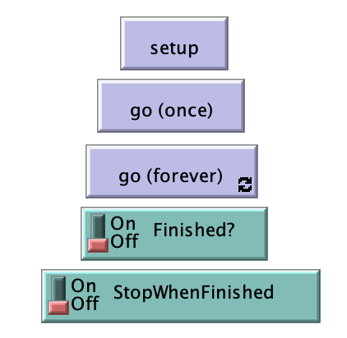

**Simulation controls**

The setup button sets up the simulation with the current settings. In order for some changes to take affect (e.g change in population the simulation must be set up again after the changes.

The go buttons start the simulation; go (once) only runs the simulation for 1 tick whereas go (forever) runs the simulation forever or until it is stopped.

Contrarily, the Finished? switch is used to stop the simulation early. If the switch is turned on, the next time the agents will come across the container they will stop. The StopWhenFinished switch will have the simulation running until all the rubbish is collected. This is exceptionally good for testing the efficiency of an agent by counting the number of ticks it takes to pick up all the rubbish

**Agent controls and parameters**

Here are all the controls and parameters for the agents.

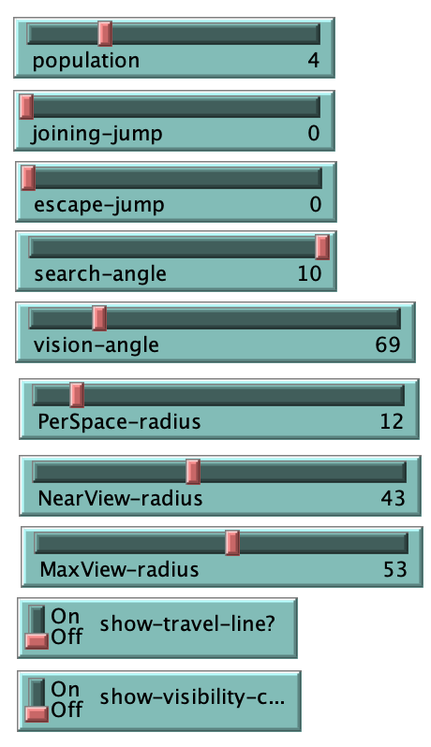The population sliders set the number of agents that will be spawned in the simulation.

Sliders joining-jump and escape-jump are for swarming feature only. They set the number of patches an agent will jump towards another agent if it detects it in its MaxView vision cone and the number of patches it will jump away from an agent if it detects it in its PerSpace vision cone respectively.

The vision angle slider sets the angle of the 3 vision cones, and the next 3 sliders sets the length of the grey, orange and red vision cone respectively. Vision-cone Per-Space radius is used to suck up waste and avoid collision with other agents. NearView-radius is used for following other agents as part of swarm movement and MaxView-radius is used for avoiding obstacles and detecting waste.

The show-travel-line? switch at the bottom can be turned on to make agents leave a trail behind so that their path can be analysed.

The show-visibility-cone? switch visually displays the vision cones on the agents. When off the vision cones will not be displayed.

**Feature Controls**

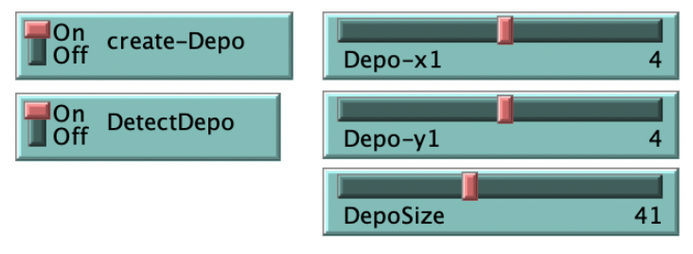

This cluster of controls the big container also known as the Depo agent. The switch create-Depo allows the user to toggle the Depo on and off with the 3 sliders regulating its x and y coordinates and the size of the depo. The DetectDepo switch toggles the agents ability to recognise the depo using the red vision cone.

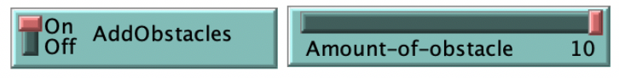Switching on the AddObstacles switch will randomly insert a number of obstacles into the simulation. This number depends on the Amount-of-obstacle slider.

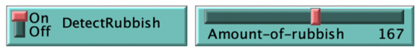The amount of waste randomly scattered around the environment is controlled by the Amount-of-rubbish slider. The DetectRubbish switch toggles the agents

ability to see the waste inside the red vision cone.

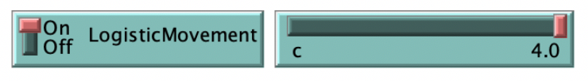

The LogisticMovement switch controls the movement of the agents. If off the movement is random and if on the movement is logistic. The slider changes the C value

Used in calculating the logistic movement. The higher the

C value, the bigger the turn

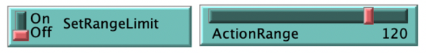Here we can turn on a range limit for the agents scaled by the ActionRange slider. If the SetRangeLimit switch is on the agents will stay within the range specified. The

Origin of the range is the container or depo agent.

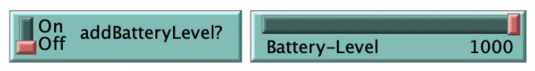

Here we can add a battery level to the agent. The battery feature can be switched on by putting the

addBatteryLevel? switch to On, and can set the power

of the battery by the Battery-Level slider. Once the

battery level on an agent has depleted, it will have to stop

to recharge.

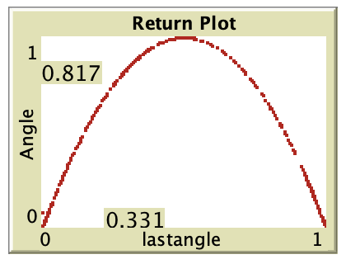

The graph at the bottom is used for testing purposes to check if the agents are using logistic movement. You know the agents are following logistic movement when the graph looks like the one in the picture.

**Appendix B – Implementation and Testing**

**Figure 1 -** Code to show the implementation of agents

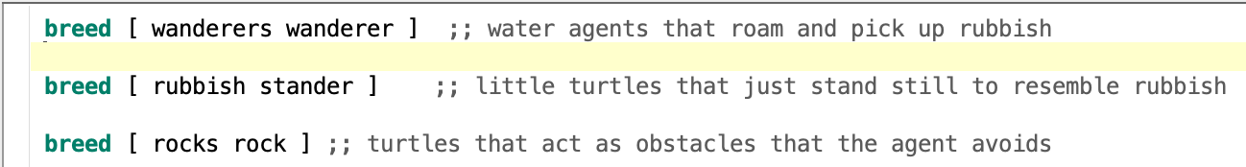

**Figure 2 -** Code to show how the waste is picked up

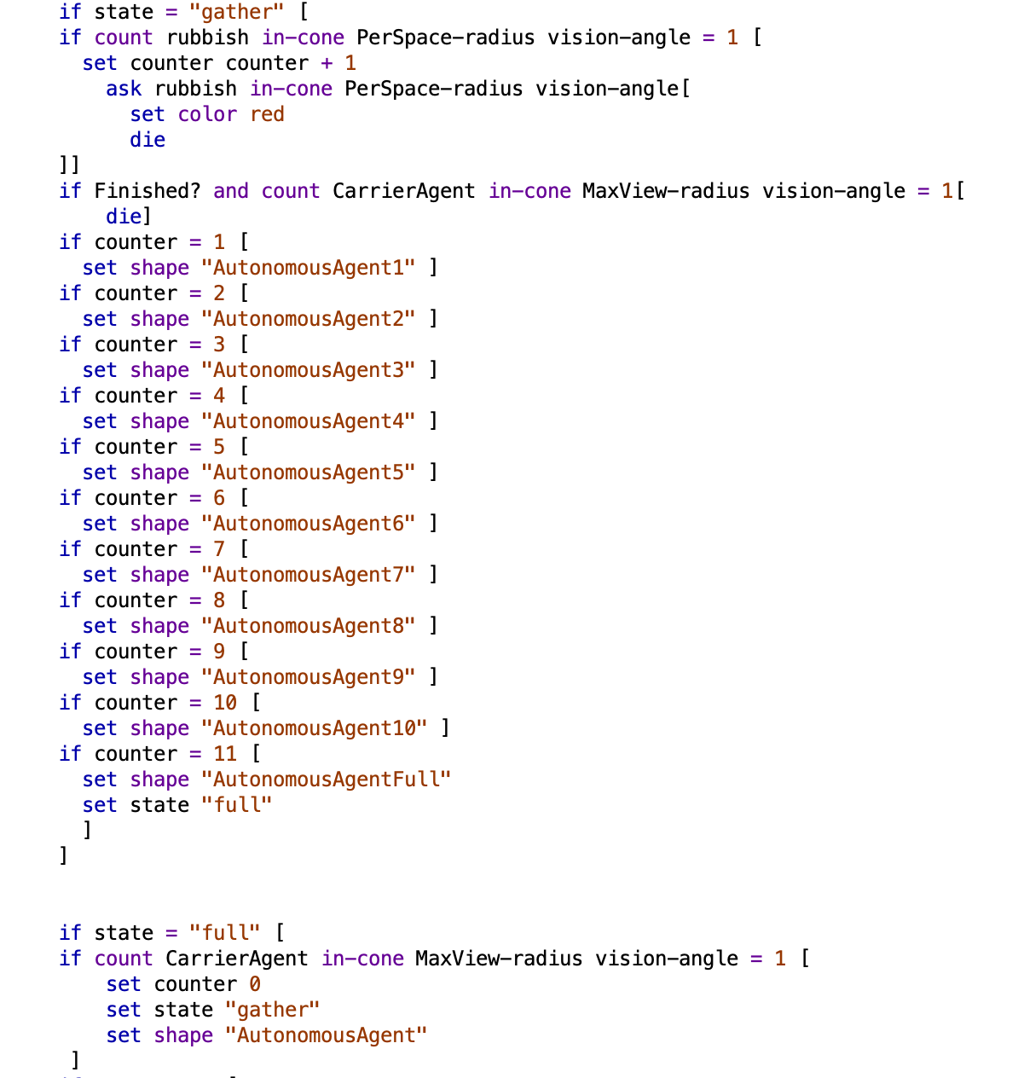

**Figure 3 -** Code to show how waste is detected

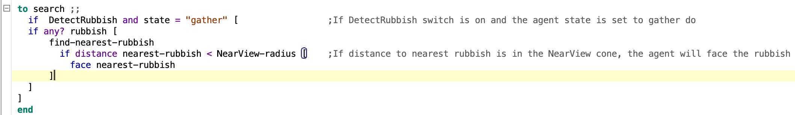

**Figure 4 -** Code to show how Obstacles are detected

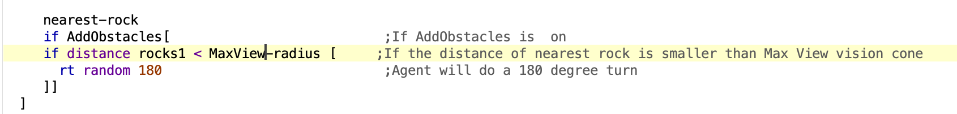

**Figure 5 -** Code to show the flocking feature

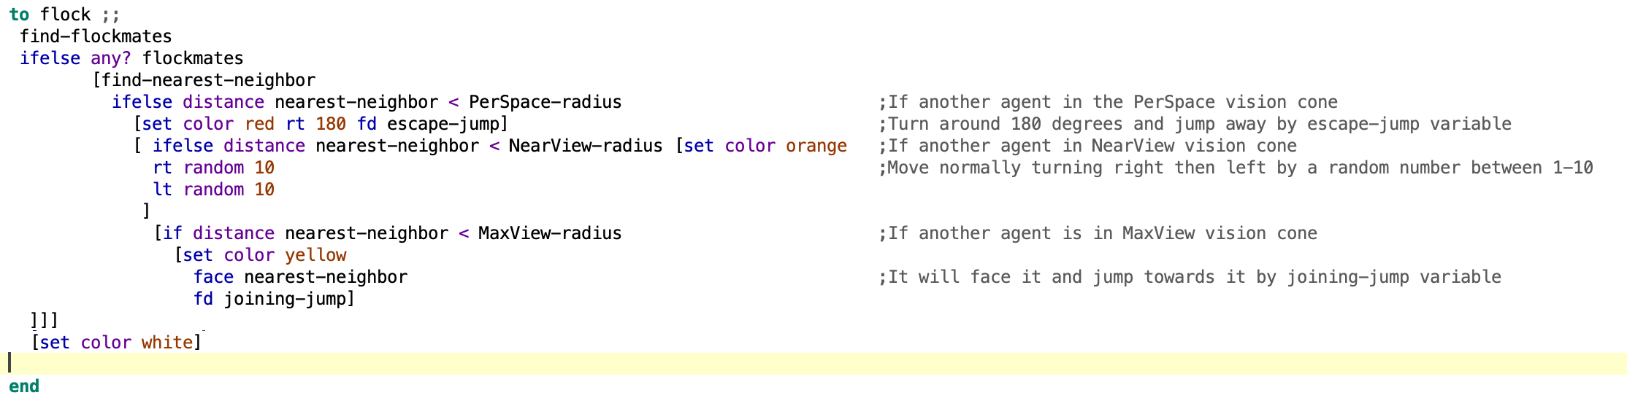

**Figure 6 -** Code to show how the battery function works

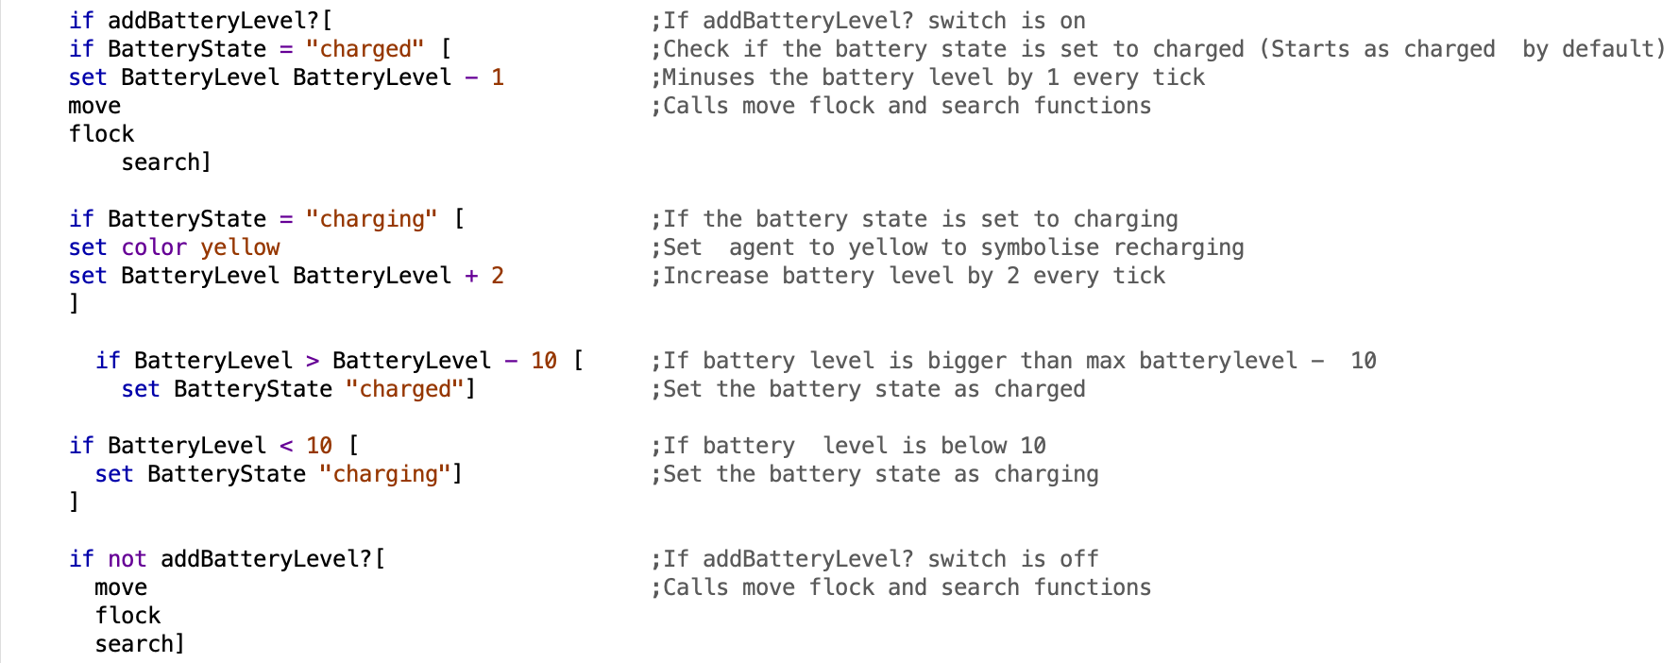

**Figure 7 -** Code to show how agents move

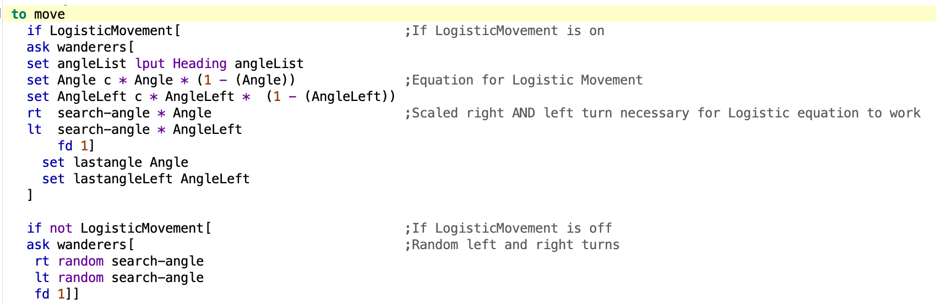

**Figure 8 -** Code to show how the graph is implemented



**Figure 9 -** Code to show changes to LogisticMovement

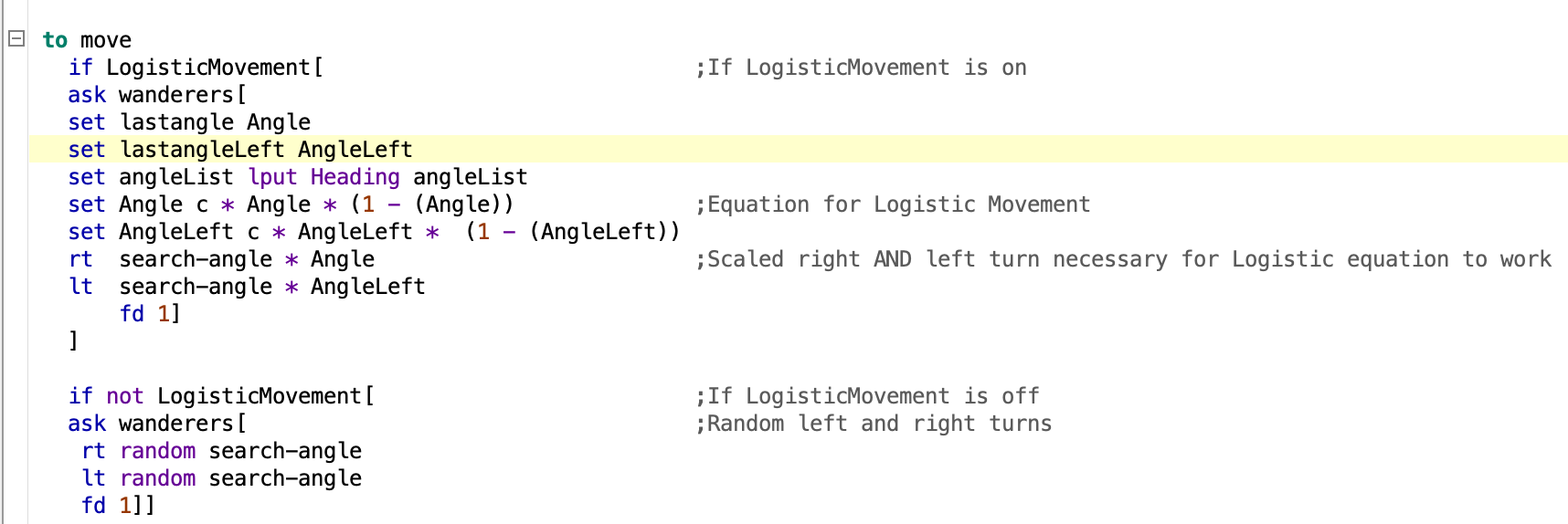

**Figure 10 -** Code to show addition of Depo agent

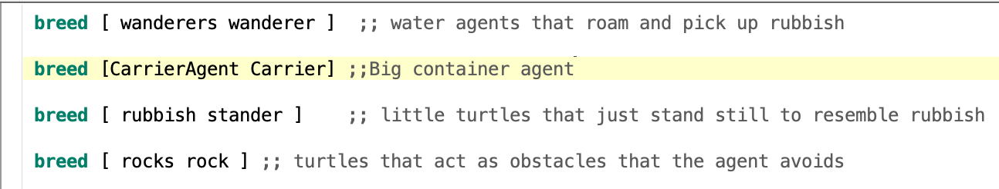

**Figure 11 -** Table to show tick results of different population and movement

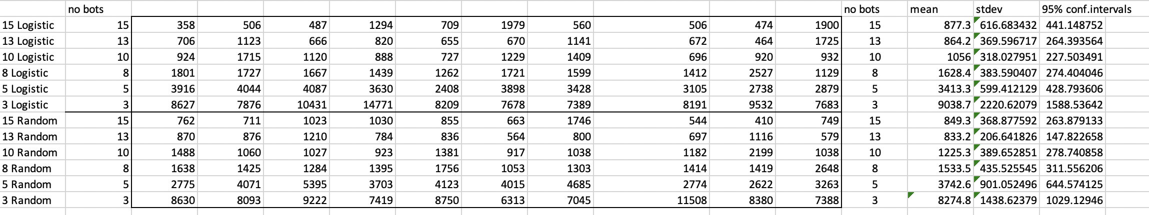

**Figure 12 -** Table to show tick results of different search-angle values and movement

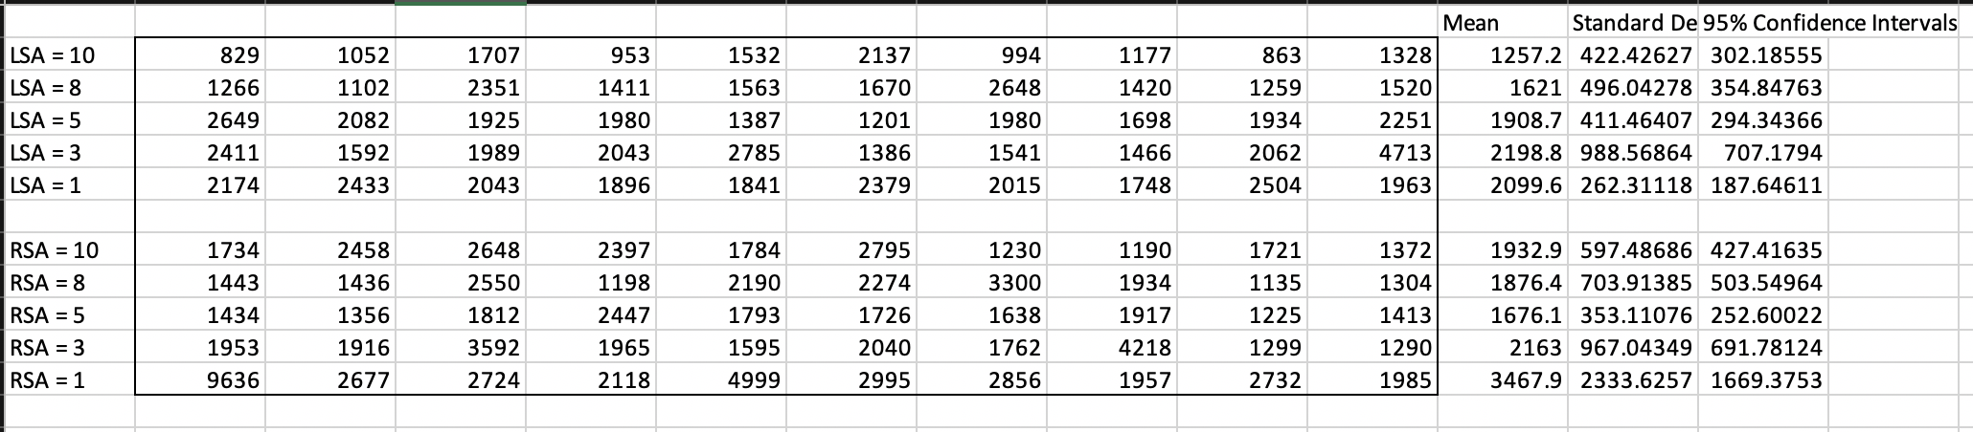

**Figure 13 -** Table to show different C values

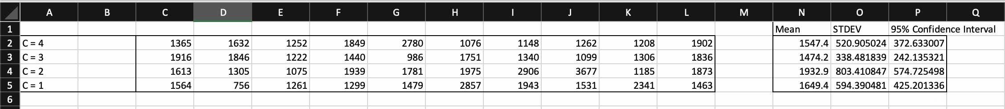

**Figure 14 -** Table to show tick results with DetectRubbish switch on and off

|  |  |  |  |  |  |  |  |  |  |  |  |
| --- | --- | --- | --- | --- | --- | --- | --- | --- | --- | --- | --- |
| Switch | 1 | 2 | 3 | 4 | 5 | 6 | 7 | 8 | 9 | 10 | Avg. |
| On | 235 | 326 | 306 | 306 | 324 | 308 | 287 | 288 | 314 | 310 | 309 |
| Off | 1480 | 1187 | 1114 | 826 | 1181 | 826 | 908 | 1069 | 1101 | 903 | 1060 |

**Appendix C – Full code**

**Figure 1 – Agent File -** Full code for Water Cleaning Agents

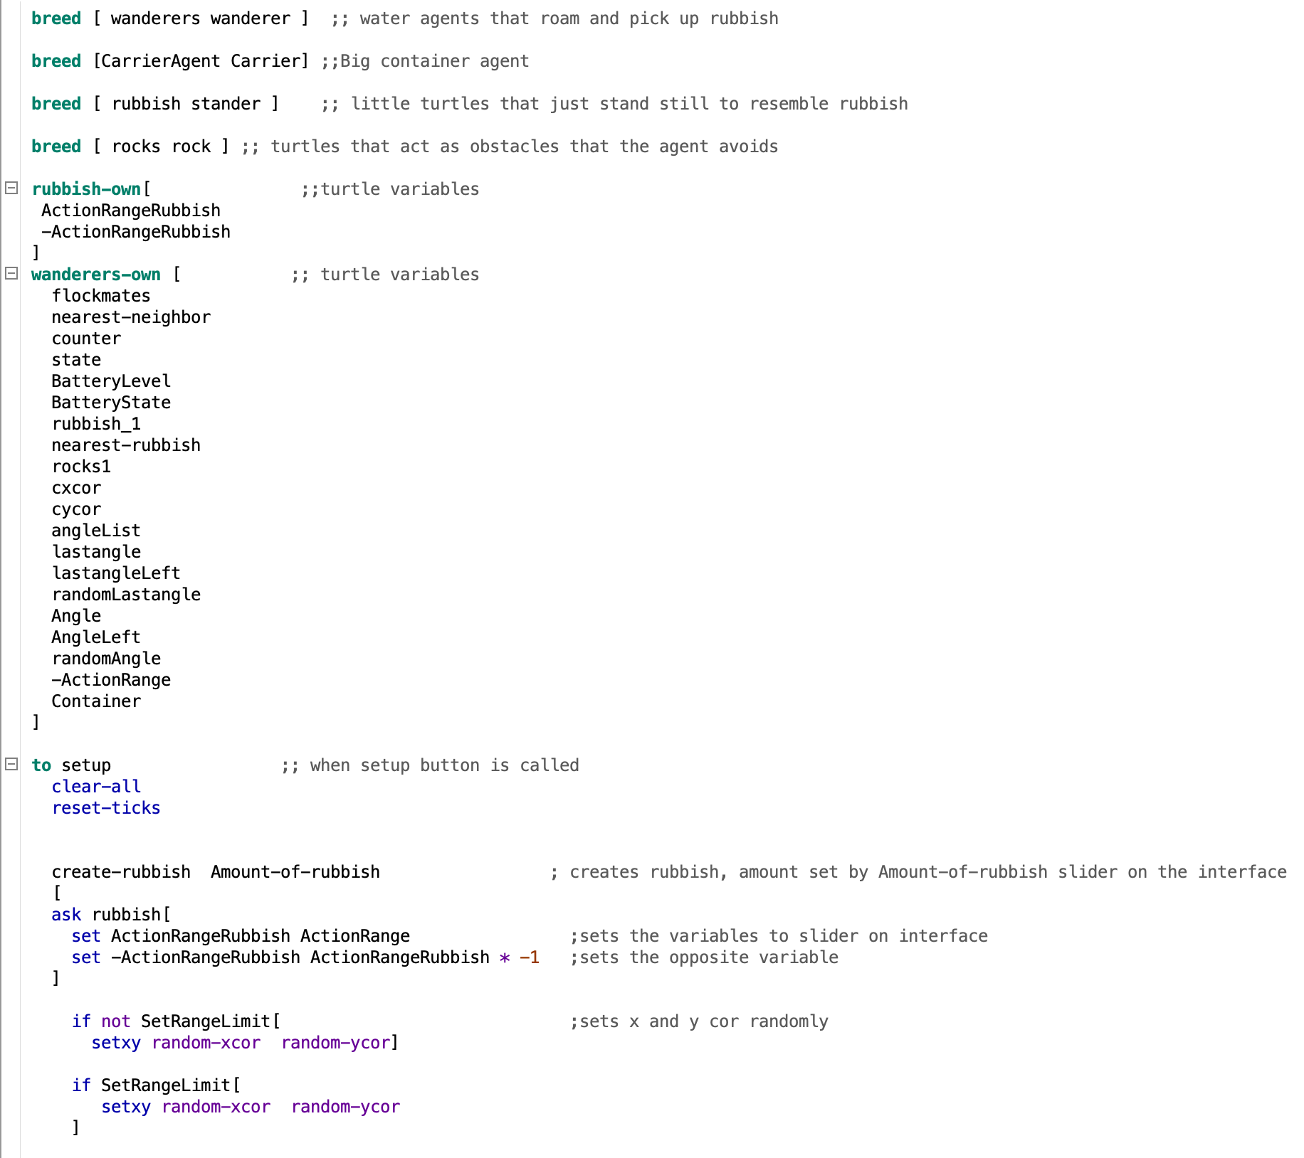

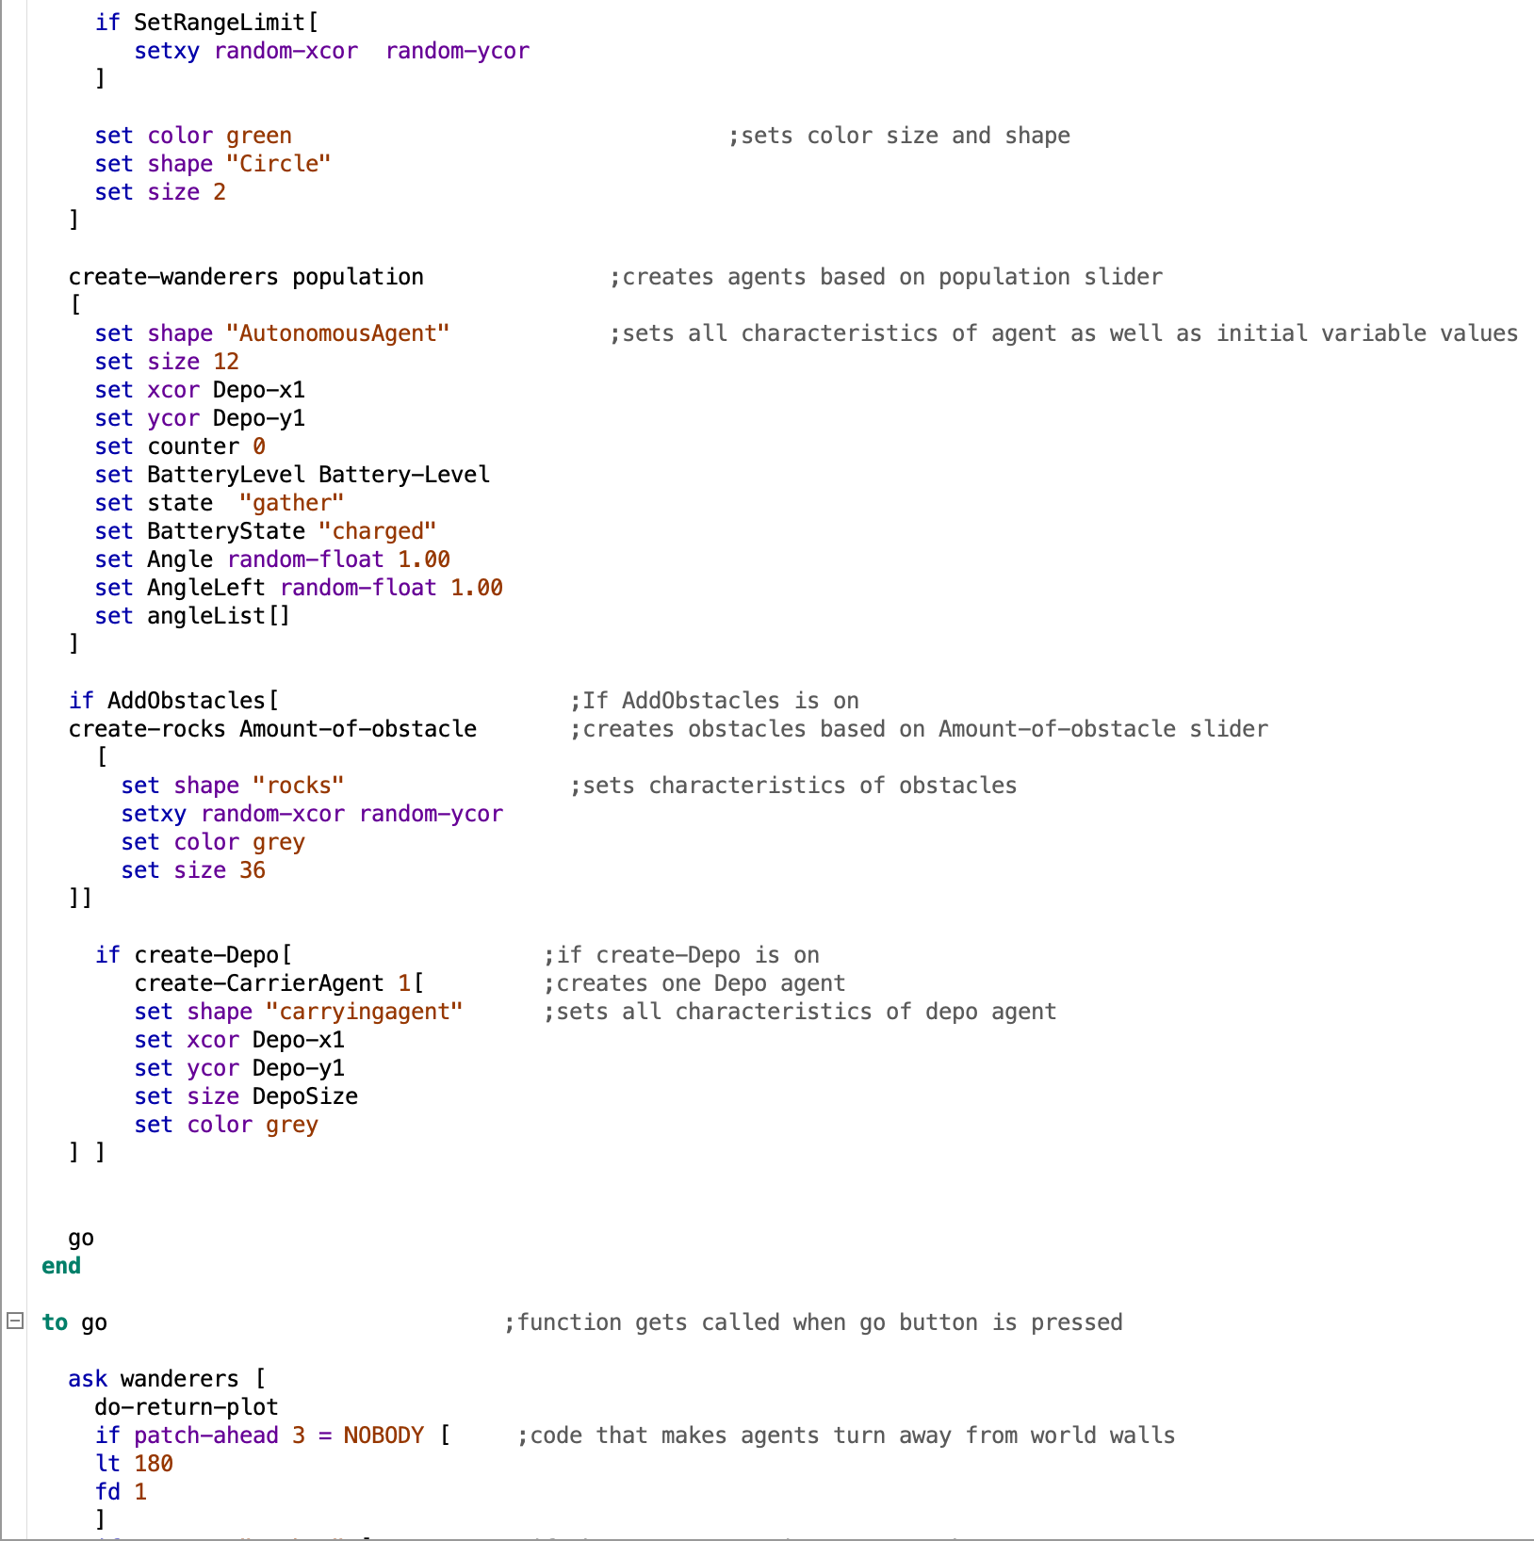

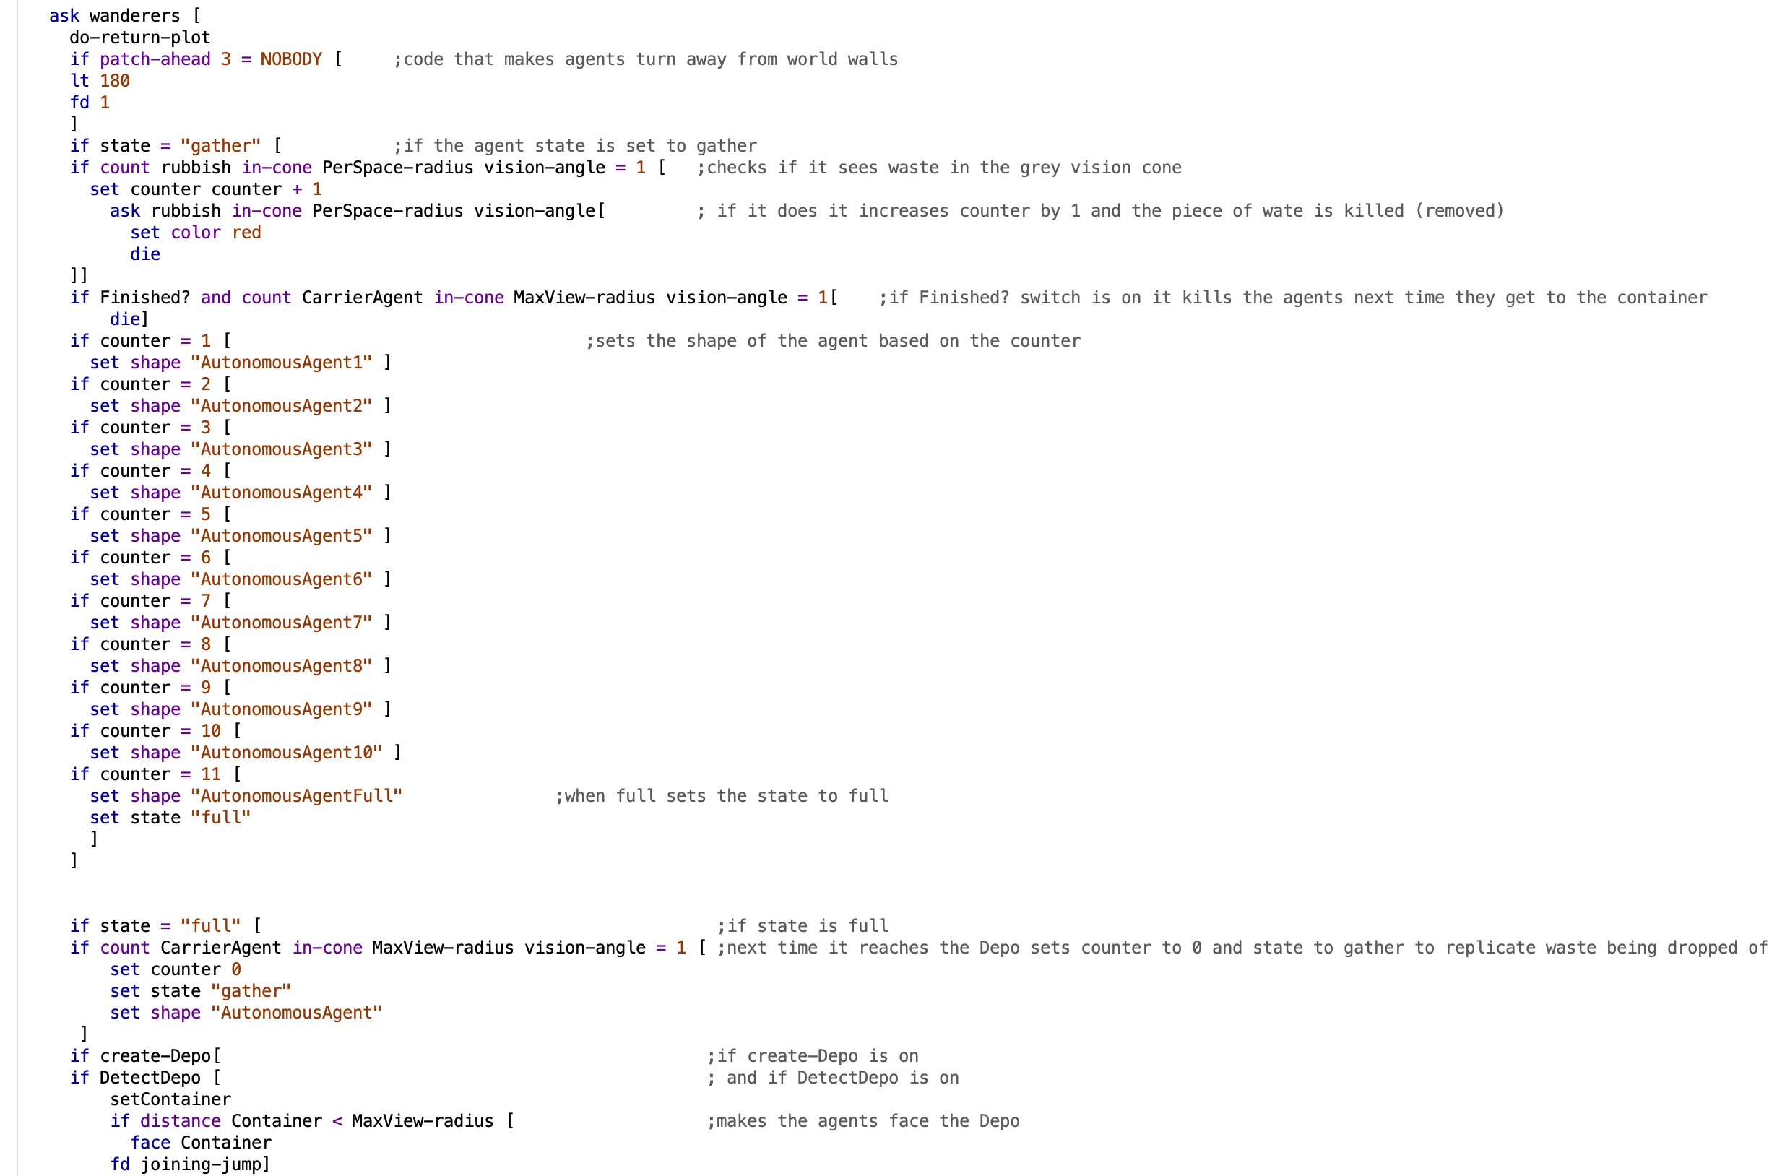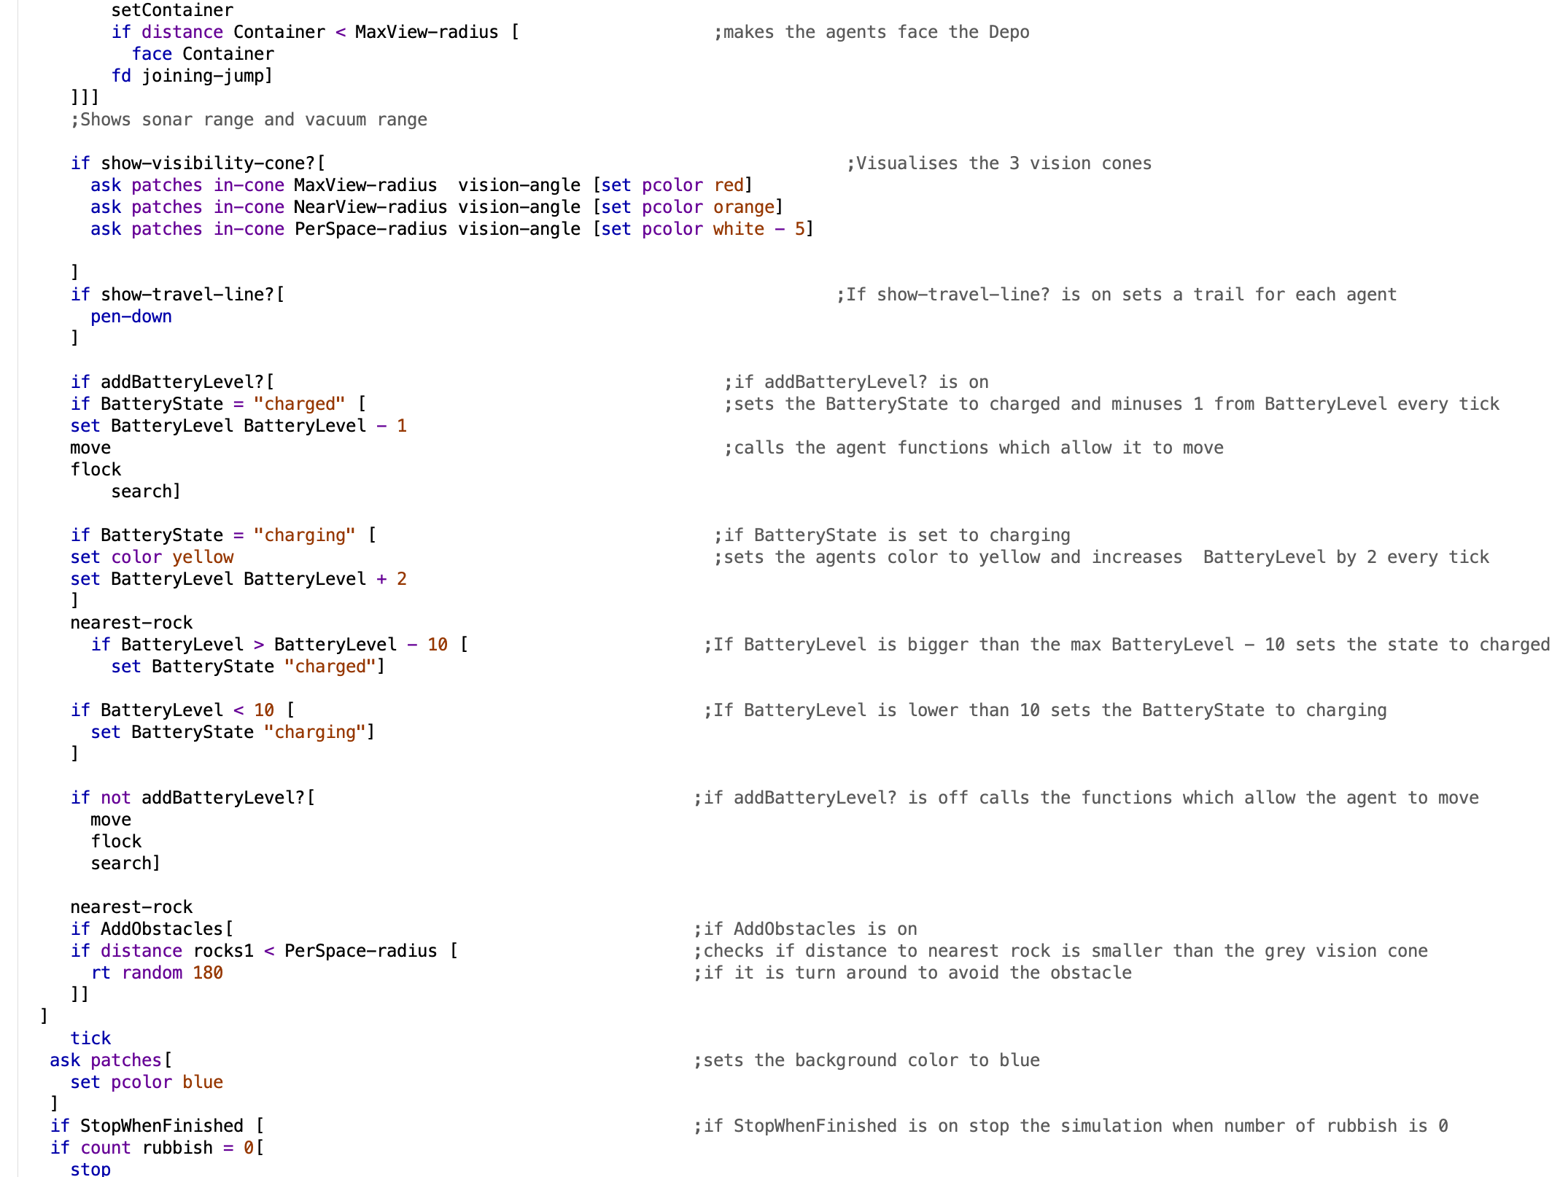

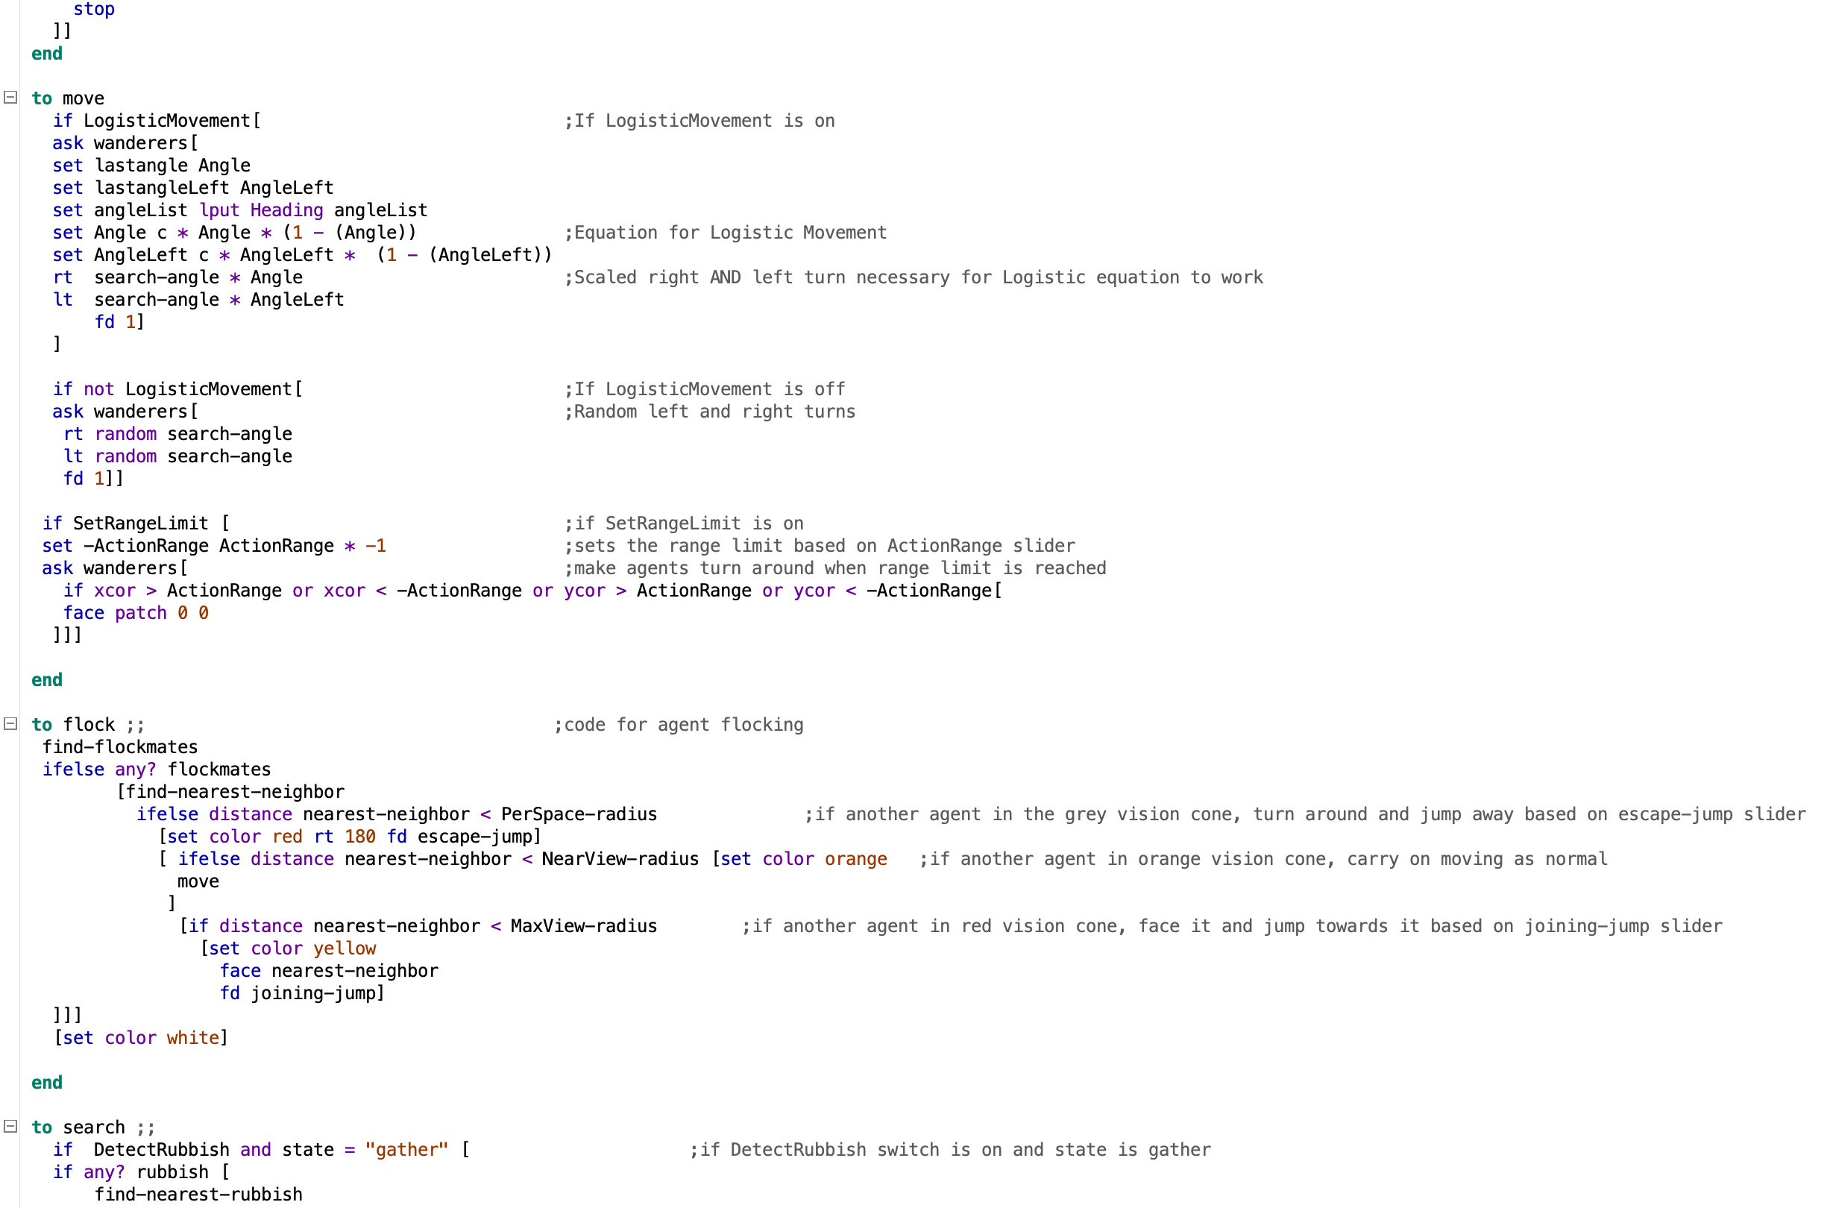

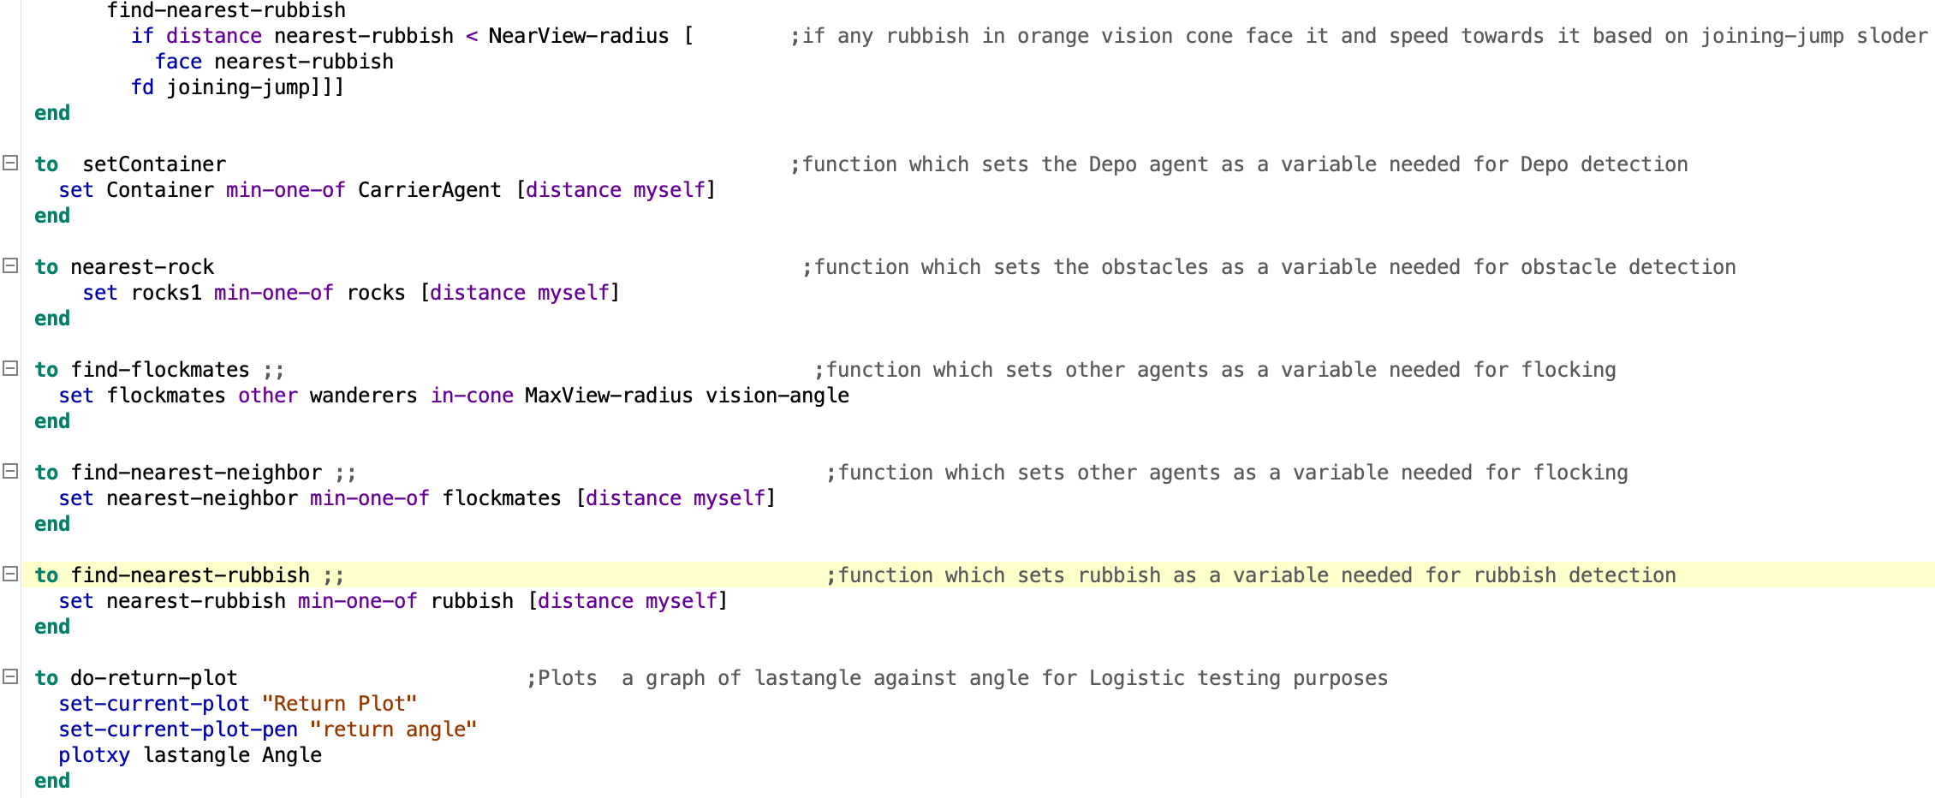

**Figure 2 – Depo File -** Full code to show Depo agent controller

